List Of Programs For Practical File:

Class -XII

- A Smith number is a composite number, the sum of whose digits is the sum of the digits of its prime factors obtained as a result of prime factorization (excluding 1). The first few such numbers are 4, 22, 27, 58, 85, 94, 121 ………………..

Examples: 666

Prime factors are 2, 3, 3, and 37

Sum of the digits are (6+6+6) = 18

Sum of the digits of the factors (2+3+3+(3+7)) = 18

- Number Conversion-Using 3 different functions:

  - Decimal-binary

•Decimal-octal

  - Decimal-Hexadecimal

- Write a Program to Add 2 Time objects.

- Write a Program to find the midpoint of two points.

5.Write a Program to check Validity of a date format and then print the date in the following format.

Eg:- Input: 12/6/2020

Output: Valid.

12th June,2020.

- Write a Program to Create two array A [ ] and B [ ] having size m and n respectively, create a third array C [ ] which will merge array A [ ] and B [] together and store in it and print array C[].

- Write a Program to Search a particular element of an array using Binary Search

Technique.

- Write a Program to Create 2 arrays A [ ] and B [ ] having size m and n respectively create a third array C [ ] which will store all the common elements of A [ ] and B [ ].

- Write a Program to Input a Sentence which ends with a full stop and print the words of the sentence in the following format:-

Input: City Of Joy.

Output: Joy Of City.

- Write a Program to Input a sentence and arrange the words of the sentence in alphabetical order.

Input: I live in Kolkata.

Output: I in Kolkata live.

- Write a Program to Input a sentence and arrange the words of the sentence in ascending order of their length.If two words are of same length then arrange them Alphabetically.

- A Circular Prime is a prime number that remains prime under cyclic shifts of its digits. When the leftmost digit is removed and replaced at the end of the remaining string of digits, the generated number is still prime. The process is repeated until the original number is reached again.

Example:

131

311

113

Hence, 131 is a circular prime.

13. Write a Program to find Sum of left and right diagonal of a matrix.

- Write a Program to Input a matrix and check whether it is identity matrix or not.(Dimension of the matrix to be read from the user).

- Write a Program to Create a square matrix and arrange each and every row in either ascending or descending order.
- Write a Program to Write a Program to Create a square matrix and sort elements of each and every column of the matrix in ascending order.

17. Write a Program to find the Transpose of a matrix.

18. Write a Program to Check whether a matrix is symmetric matrix or not.

19. Write a Program to find Saddle point of a matrix.

- Write a program to create a square matrix of m*m order and find out the sum of boundary and non boundary elements of the matrix.

21. Implement Stack data structure. Define push(),pop() and display() method.

22. Implement Queue data structure. Define insert(),delete() and display() method.

23. Implement Circular Queue data structure. Define insert(),delete() and display() method.

- Write a Program in Java to fill a square matrix of size ‘n*n” in a circular fashion (clockwise) with natural numbers from 1 to n*n, taking ‘n’ as input.

For example: if n = 4, then n*n = 16, hence the array will be filled as given below.

- Write a program to declare a square matrix A[][] of order (M x M) where ‘M’ must be greater than 3 and less than 10. Allow the user to input positive integers into this matrix. Perform the following tasks on the matrix:

- Sort the boundary elements in descending order using any standard sorting technique and rearrange them in the matrix.

- Display the original matrix, rearranged matrix.

Test your program with the sample data and some random data:

Example 1

INPUT :M = 4

ORIGINAL MATRIX

9215

81384

156 3 11

7 12238

OUTPUT:

REARRANGED MATRIX

23 15 12 11

11389

2638

4578

- Design a program to accept a day number (between 1 and 366), year (in 4 digits) from the user to generate and display the corresponding date. Also, accept ‘N’ (1 <= N <= 100) from the user to compute and display the fu ture date corresponding to ‘N’ days after the generated date. Display an error message if the value of the day number, year and N are not within the limit or not according to the condition specified.

INPUT:

DAY NUMBER: 255

YEAR: 2018

DATE AFTER (N DAYS): 22

OUTPUT:

DATE: 12 TH SEPTEMBER, 2018

DATE AFTER 22 DAYS: 4 TH OCTOBER, 2018

- Write a program to accept a sentence which may be terminated by either’.’, ‘?’or’!’ only. The words may be separated by more than one blank space and are in UPPER CASE.

Perform the following tasks:

- Find the number of words beginning and ending with a vowel.

- Place the words which begin and end with a vowel at the beginning, followed by the remaining words as they occur in the sentence.

INPUT: YOU MUST AIM TO BE A BETTER PERSON TOMORROW THAN YOU ARE TODAY.

OUTPUT: NUMBER OF WORDS BEGINNING AND ENDING WITH A VOWEL= 2

A ARE YOU MUST AIM TO BE BETTER PERSON TOMORROW THAN YOU TODAY

28. Write a Program in Java to input a number and check whether it is an Evil Number or not.

Evil Number : An Evil number is a positive whole number which has even number of 1’s in its binary equivalent.

Example: Binary equivalent of 9 is 1001, which contains even number of 1’s.

A few evil numbers are 3, 5, 6, 9…
Design a program to accept a positive whole number and find the binary equivalent of the number and count the number of 1’s in it and display whether it is a Evil number or not with an appropriate message. Output the result in format given below:

INPUT : 15

BINARY EQUIVALENT : 1111

NO. OF 1’s : 4

OUTPUT : EVIL NUMBER

29. The encryption of alphabets are to be done as follows:

A=1

B=2

C=3

.

.

.

Z=26

The potential of a word is found by adding the encrypted value of the alphabets.

Example: KITE

Potential = 11 + 9 + 20 + 5 = 45

Accept a sentence which is terminated by either “ . ” , “ ? ” or “ ! ”. Each word of sentence is separated by single space. Decode the words according to their potential and arrange them in ascending order.

Output the result in format given below:

INPUT | : | THE SKY IS THE LIMIT.
POTENTIAL |  | :THE | = 33
 |  | SKY | = 55
 |  | IS | = 28
 |  | THE | = 33
 |  | LIMIT | = 63
OUTPUT |  | : IS THE THE SKY LIMIT

Date: 18.09.20

- Write a Program in Java to input a 2-D square matrix and check whether it is a Diagonal Matrix or not.

Diagonal Matrix : A diagonal matrix is a matrix (usually a square matrix) in which the entries outside the main diagonal are all zero. The diagonal entries themselves may or may not be zero (but all diagonal entries cannot be zero).

Example:

5000

0100

0000

0007

- Input a sentence from user and print all the palindrome words present in that sentence. Also print the

frequency of the palindrome words.

- Write a program to input a string (word). Convert it into lowercase letters. Count and print the frequency of each alphabet present in the string. The output should be given as:
Sample Input: Alphabets

Sample Output:

==========================

Alphabet Frequency

==========================

a 2

b 1

e 1

h 1

l 1

p 1

s 1

t 1

33. Write a Program in Java to input a number and check whether it is a Unique Number or not.

Note: A Unique number is a positive integer (without leading zeros) with no duplicate digits. For example 7, 135, 214 are all unique numbers whereas 33, 3121, 300 are not.

34. Write a program to check whether a number is prime or not using recursive method.

35. Write a program to print first ‘n’ fibonacci numbers using recursive method.

36. Write a program to print the greatest common divisor of 2 numbers using recursive method.

37. Write a program to print the reverse of a string using recursive method.

38. Perform Binary search using recursive method.

- A super class Perimeter has been defined to calculate the perimeter of a parallelogram. Define a subclass Area to compute the area of the parallelogram by using the required data members of the super class. The details are given below:

Class name : Perimeter

Data members/instance variables:

a : to store the length in decimal

b : to store the breadth in decimal

Member functions:

Perimeter( … ) : parameterized constructor to assign values to data members

double Calculate( ) : calculate and return the perimeter of a parallelogram as 2 * (length + breadth)

void show() : to display the data members along with the perimeter of the parallelogram

Class name : Area

Data members/instance variables:

h : to store the height in decimal

area : to store the area of the parallelogram

Member functions:

Area( … ) : parameterized constructor to assign values to data members of both the classes

void doarea( ) : compute the area as (breadth * height)

void show() : display the data members of both classes along with the area and perimeter of the parallelogram.

Specify the class Perimeter giving details of the constructor( … ), void Calculate( ) and void show( ). Using the concept of inheritance, specify the class Area giving details of the constructor( … ), void doarea( ) and void show( ).

40. A super class Bank has been defined to store the details of a customer. Define a

subclass Account that enables transactions for the customer with the bank. The details of both the classes are given below:

Class name: Bank

Data members/instance variables:

name: stores the name of the customer.

accno: stores the account number.

- stores the principal amount in decimals.

Member functions/methods:

Bank(…): parameterized constructor to assign values to the instance variables.

void display(): displays the details of the customer.

Class name: Account

Data members/instance variables:

amt: stores the transaction amount in decimals.

Member functions/methods:

Account(…): parameterized constructor to assign values to the instance variables of both the classes.

void deposit(): accepts the amount and updates the principal as p = p + amt.

void withdraw(): accepts the amount and updates the principal as p = p – amt. If the withdrawal amount is more than the principal amount, then display the message “INSUFFICIENT BALANCE”. If the principal amount after withdrawal is less than 500, then a penalty is imposed by using the formula p = p – (500 – p) / 10.

void display(): displays the details of the customer.

PROGRAM-1

class Smith_main

{

public static void main(String args[])

{

Smith obj=new Smith();

obj.read();

obj.check();

}

}

import java.util.Scanner;

class Smith

{

int n;

void read()

{

Scanner sc=new Scanner(System.in); System.out.println("Enter a number");
n=sc.nextInt();

}

int sum_of(int x)

{

int s=0,d;

while(x>0)

{

d=x%10;

x=x/10;

s=s+d;

}

return s;

}

void check()

{

int a=n;
int p=sum_of(a);

int f=2;

int sum=0;

while(a>1)

{

if(a%f==0)

{

sum=sum+sum_of(f);

a=a /f;

}

else

{

f++;

}

}

System.out.println("the sum of the digits "+sum);

System.out.println("the sum of the prime factors "+p);
if(p==sum)

System.out.println(n+" is a smith number");

else

System.out.println(n+" isn't a smith number");

}

}
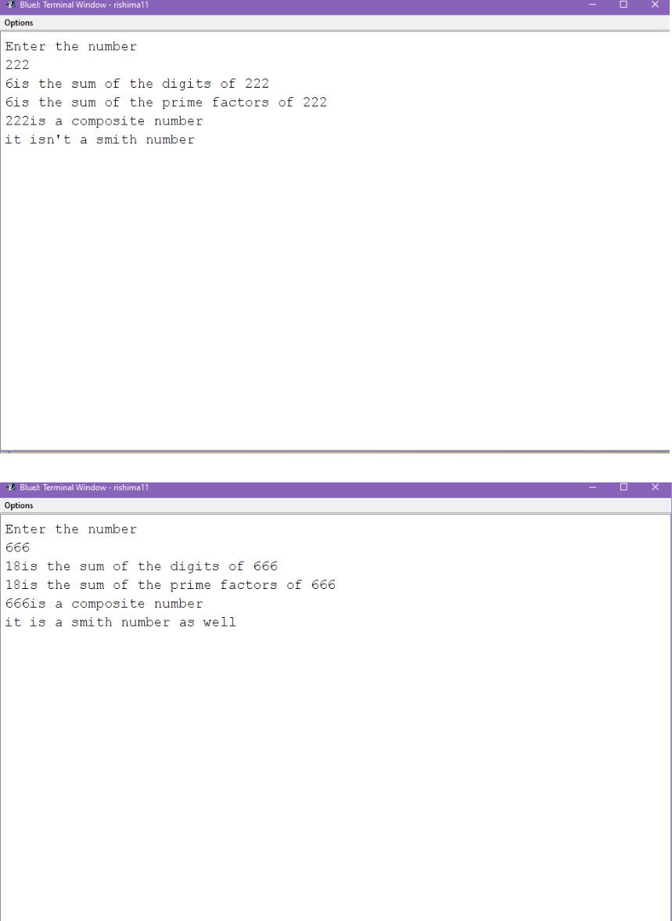
PROGRAM-2

import java.util.Scanner;

class Conversion_Main

{

public static void main(String args[])

{

int a;

Scanner sc=new Scanner(System.in); System.out.println("enter a no"); a=sc.nextInt();

Conversion obj=new Conversion();

obj.dec_bin(a);

obj.dec_oct(a);

obj.dec_hex(a);

}

}

import java.util.Scanner;

class Conversion
{

void dec_bin(int n)

{ String x="";

for(int a=n;a>0;a=a/2)

{

x=(a%2)+x;

}

System.out.println("The decimal equivalent ="+x);

}

void dec_oct(int n)

{

String x="";

for(int a=n;a>0;a=a/8)

{

x=(a%8)+x;

}

System.out.println("The octal equivalent ="+x);
}

void dec_hex(int n)

{

String x="";

char arr[]={'A','B','C','D','E','F'}; for(int a=n;a>0;a=a/16) {

if(a%16>9)

x=arr[(a%16)-10]+x;

else

x=(a%16)+x;

}

System.out.println("The hexadecimal equivalent ="+x);

}

}
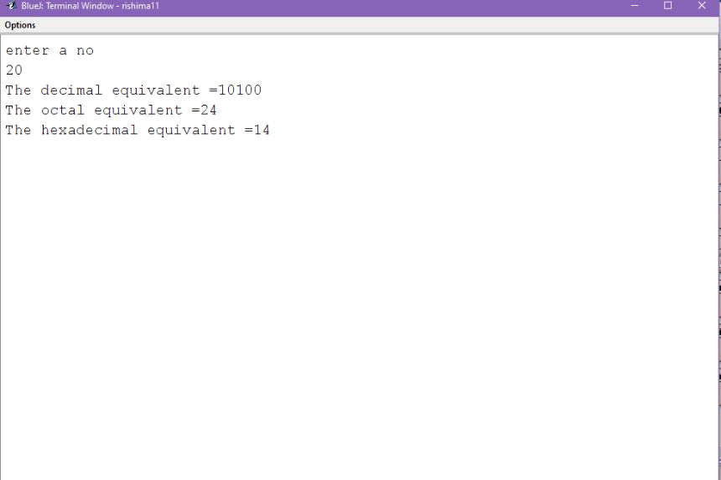

PROGRAM-3

import java.util.Scanner; class Time_main {

public static void main(String args[])

{

Time t1=new Time();

Time t2=new Time();

t1.input();

t2.input();

t1.show();

t2.show();
Time t3=new Time();

t3.add(t1,t2);

t3.show();

}

}

import java.util.Scanner;

class Time

{

int hour,min;

void input()

{

Scanner sc=new Scanner(System.in);

System.out.println("enter the time");

hour=sc.nextInt();

min=sc.nextInt();

}
void show()

{

System.out.println("The time is "+hour+":"+min);

}

void add(Time t1,Time t2)

{

hour=t1.hour+t2.hour;

min=t1.min+t2.min;

hour=hour+min/60;

min=min%60;

}

}
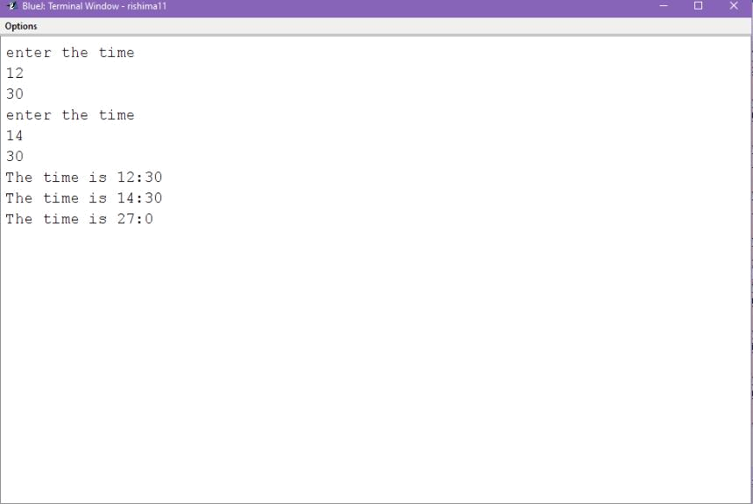

PROGRAM-4

import java.util.Scanner;

class Point_New

{

int x,y;

Point_New()

{

x=0;

y=0;

}

Point_New(int x1,int y1)
{

x=x1;

y=y1;

}

void display()

{

System.out.println("co-ordinates are ("+x+","+y+")");

}

void mid_pt(Point_New pt,Point_New pt1)

{

double mid,mid1;

mid=(pt.x+pt.y)/2.0;

mid1=(pt1.x+pt1.y)/2.0;

System.out.println("mid pts of the lines are"+mid+"and"+mid1);

}

}

import java.util.Scanner;
class ____Point____New____Main____

{

public static void main(String args[])

{

Scanner sc=new Scanner(System.in);

int a,b,c,e;

System.out.println("enter the points");

a=sc.nextInt();

b=sc.nextInt();

c=sc.nextInt();

e=sc.nextInt();

Point pt=new Point(a,b);

Point pt1=new Point(c,e);

pt.display();

pt1.display();

Point pt2=new Point(0,0);

pt2.mid_pt(pt,pt1);

}
}
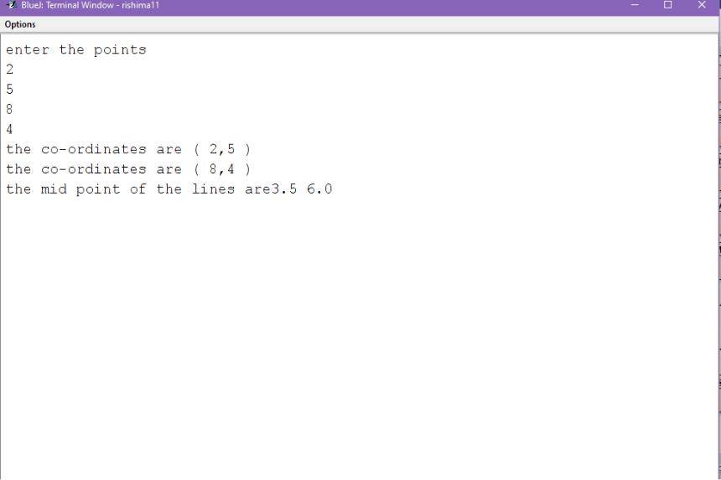

PROGRAM-5

import java.util.Scanner;

class Date_Val

{

public static void main(String args[])

{

String date="",r="";

int len=0,a1=0,b1=0,c=0;

Scanner sc=new Scanner(System.in);

System.out.println("Enter a date in format dd/mm/yyyy");
date=sc.next();

int a[]={31,28,31,30,31,30,31,31,30,31,30,31};

String

b[]={"January","February","March","April","May","Jun

e","July","August","September","October","November

","December"};

len=date.length();

if(len==10)

{

a1=Integer.parseInt(date.substring(0,2));

b1=Integer.parseInt(date.substring(3,5));

c=Integer.parseInt(date.substring(6));

if(c%100==0&&c%4==0||c%400==0||c%4==0)

{

if(b1!=02)

{

if(a1>0||a1<32||b1>0||b1<12)

{
if(a1==1||a1==31)

r=a1+"st";

else if(a1==2)

r=a1+"nd";

else if(a1==3)

r=a1+"rd";

else

r=a1+"th";

System.out.println("date valid"+"\n"+r+" "+b[b1-1]+" "+c);

}

else

System.out.println("the date is invalid!");

}

else if(a1<0||a1>32||b1<0||b1>12) System.out.println("the date is invalid!"); else if(b1==02)
{

a[1]=29;

if(a1==1||a1==31)

r=a1+"st";

else if(a1==2)

r=a1+"nd";

else if(a1==3)

r=a1+"rd";

else

r=a1+"th";

System.out.println("date valid"+"\n"+r+" "+b[b1-1]+" "+c);

}

}

else

System.out.println("The date is invalid!");

}
}

}
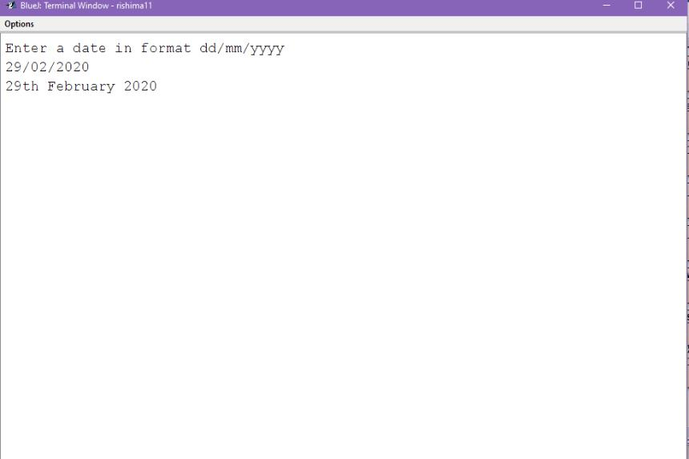

PROGRAM-6

import java.util.Scanner;

class Merge

{

public static void main(String args[])

{

int k,x,d=0;

Scanner sc=new Scanner(System.in);

System.out.println("enter 2 limits");

k=sc.nextInt();
x=sc.nextInt();

int A[]=new int[k];

int B[]=new int[x];

int C[]=new int[k+x];

System.out.println("enter elements in a");

for(int i=0;i<k;i++)

A[i]=sc.nextInt();

System.out.println("enter elements in b");

for(int i=0;i<x;i++)

B[i]=sc.nextInt();

for(int i=0;i<k;i++)

{

C[d++]=A[i];

}

for(int i=0;i<x;i++)

{

C[d++]=B[i];

}
System.out.println("enter elements in c");

for(int i=0;i<k+x;i++)

System.out.print(C[i]);

}

}
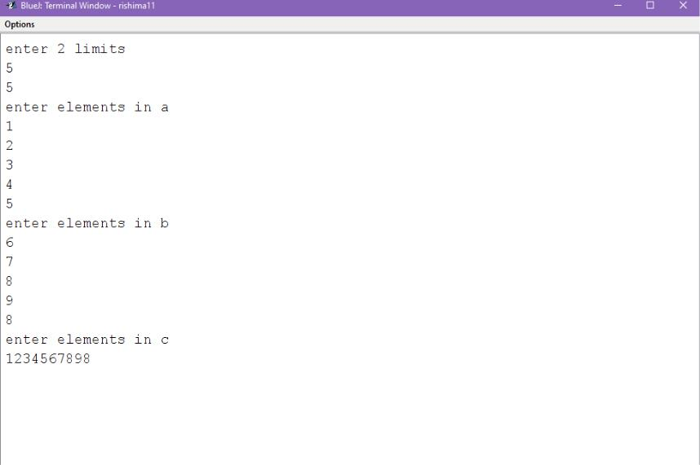

PROGRAM-7

import java.util.*;

class BinarySearch{

public static void main (String args[]){ Scanner sc=new Scanner(System.in); System.out.println("Enter the size of array :"); int n=sc.nextInt();
int a[]=new int[n];

System.out.println("Enter the elements of the array in asscending order : ");

for(int i=0;i<n;i++){

a[i]=sc.nextInt();

}

System.out.println("Enter the number to search :

");

int num=sc.nextInt();

int l=0,h=n-1,m,flag=0;

do{

m=(l+h)/2;

if(a[m]==num){

flag=1;

break;

}

else if(num>a[m]){

l=m+1;

}
else if(num<a[m]){

h=m-1;

}

}while(l<=h);

if(flag==1){

System.out.println("Number found at position

"+m);

}

else{

System.out.println("Not found..");

}

}

}
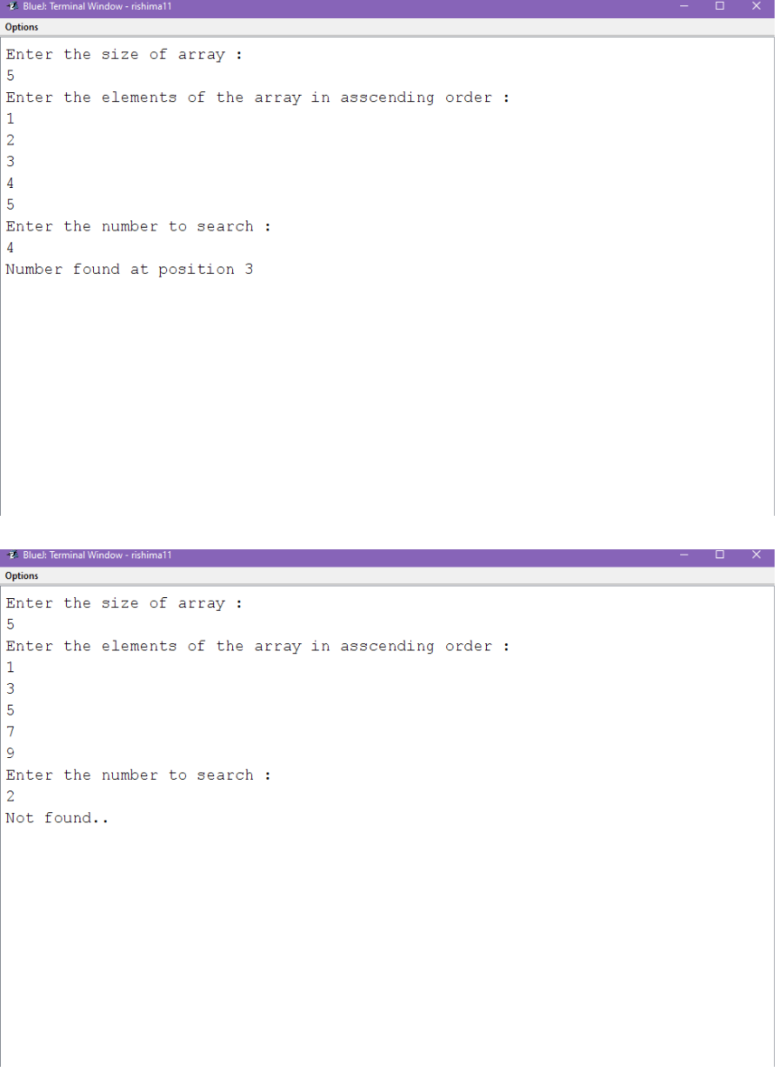

PROGRAM-8

import java.util.Scanner;

class Common

{

public static void main(String args[])

{
int m,n;

Scanner sc=new Scanner(System.in);

System.out.println("enter 2 limits");

m=sc.nextInt();

n=sc.nextInt();

int a[]=new int[m];

int b[]=new int[n];

int c[]=new int[m+n];

System.out.println("enter elements in array a:");

for(int i=0;i<m;i++)

a[i]=sc.nextInt();

System.out.println("enter elements in array b:");

for(int i=0;i<m;i++)

b[i]=sc.nextInt();

int k=0;

for(int i=0;i<m;i++)

{

for(int j=0;j<n;j++)
{

if(a[i]==b[j])

c[k++]=b[j];

}

}

System.out.println("The elements in array c:");

for(int i=0;i<m;i++)

System.out.print(c[i]+" ");

}

}
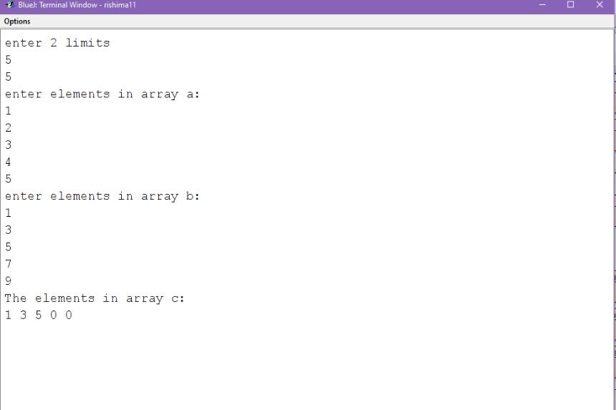

PROGRAM-9

import java.util.Scanner;
class Reverse

{

public static void main(String args[])

{

String str,r="",s="",st="";

Scanner sc=new Scanner(System.in);

System.out.println("Enter a string: ");

str=sc.nextLine();

str=str+' ';

int l=str.length();

if(str.charAt(l-2)=='.')

{

for(int i=0;i<l-2;i++)

{

st=st+str.charAt(i) ;

}

st=st+' ';

for(int j=0;j<st.length();j++)
{

if(st.charAt(j)!=' ')

r=r+st.charAt(j);

else

{

s=r+' '+s;

r="";

}

}

System.out.println("The original String "+str); System.out.println("The reversed String "+s+".");

}

else

System.out.println("Invalid string");

}

}
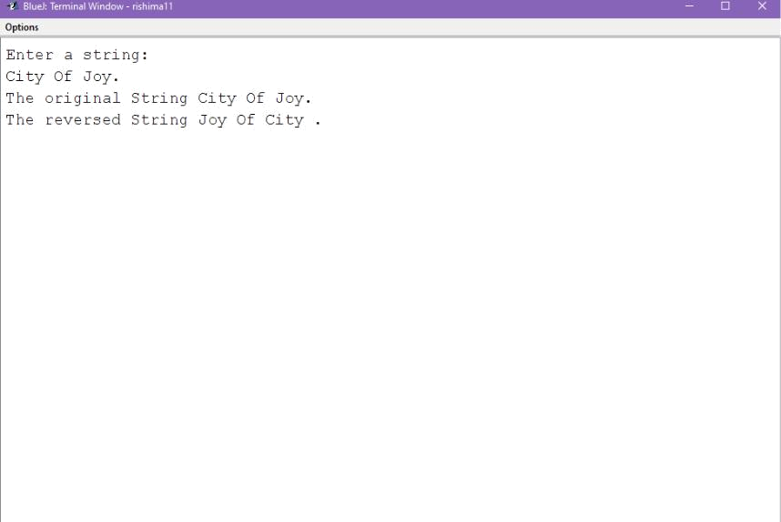

PROGRAM-10

import java.util.Scanner;

class Alphabetic

{

public static void main(String args[])

{

String s,r="",temp="";

int c=0,k=0;

Scanner sc=new Scanner(System.in);

System.out.println("enter the sentence");

s=sc.nextLine();

s=s+' ';
int l=s.length();

for(int j=0;j<l;j++)

{

if(s.charAt(j)==' ')

c++;

}

String a[]=new String[c];

for(int i=0;i<l;i++)

{

if(s.charAt(i)!=' ')

r=r+s.charAt(i);

else

{

a[k++]=r;

r="";

}

}

for(int j=0;j<c-1;j++)

{

for(int i=j+1;i<c;i++)

{

if(a[j].charAt(0)>a[i].charAt(0))

{

temp=a[i];

a[i]=a[j];

a[j]=temp;

}

}

}

System.out.println("The sorted string is"); for(int j=0;j<c;j++)
System.out.print(a[j]+" ");

System.out.print(".");

}

}
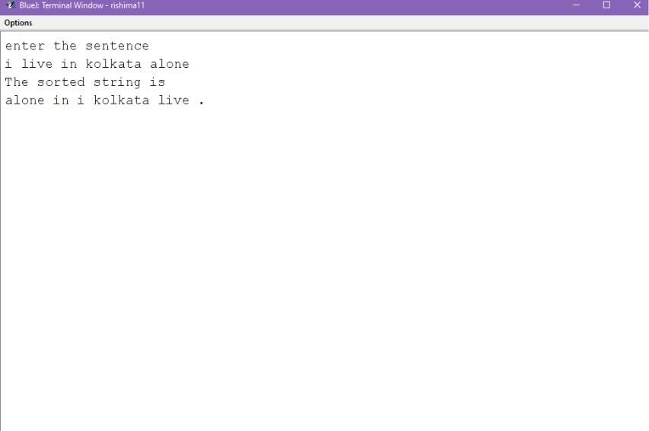

PROGRAM-11

import java.util.*;

class WordsArrange{

public static void main(String args[]){

Scanner sc=new Scanner(System.in);

System.out.println("Enter string :");

String s = sc.nextLine();
String w="",sent="";

StringTokenizer st=new StringTokenizer(s); int n=st.countTokens(); String a[]=new String[n];

int i=0;

while(st.hasMoreTokens()){

w=st.nextToken();

a[i]=w;

i++;

}

String temp;

for (int j = 0; j < n - 1; j++){ for (int k = j + 1; k < n; k++){

if (a[j].length()>a[k].length()){ temp = a[j];

a[j] = a[k];

a[k] = temp;

}
else if (a[j].length()==a[k].length()){

if (a[j].compareTo(a[k])>0){

temp = a[j];

a[j] = a[k];

a[k] = temp;

}

}

}

}

System.out.println("Sorted string is :");

for(i=0;i<n;i++){

System.out.print(a[i]+" ");

}

}

}
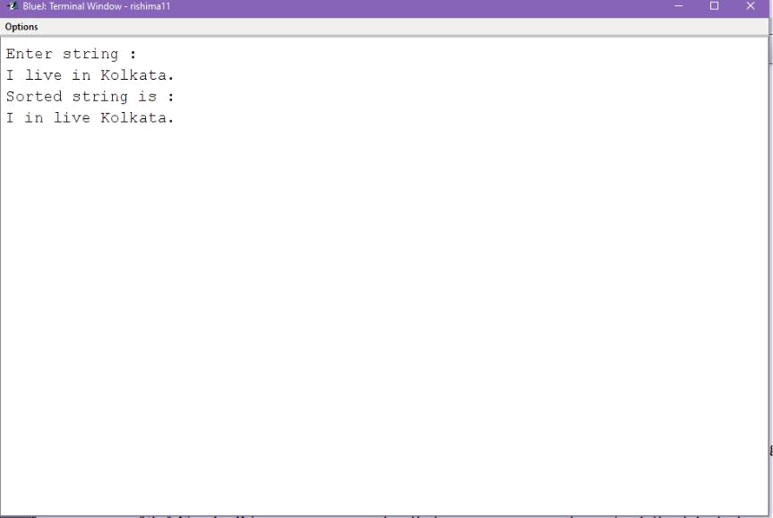

PROGRAM-12

import java.util.Scanner;

class Circular_Prime

{

public static void main(String args[])

{

Scanner sc=new Scanner(System.in); int a,c=0,d=0,f=0,e=0,s=0,g=0,r=0,k=0; System.out.println("Enter a number"); a=sc.nextInt();

for(int b=a;b>0;b=b/10)

c++;
for(int i=1;i<=a;i++)

{

if(a%i==0)

d++;

}

if(d==2)

{

int b=a;

s=b;

for(int i=1;i<=c;i++)

{

e=s%(int)Math.pow(10,c-1);

g=s/(int)Math.pow(10,c-1);

s=(e*10)+g;

for(int j=1;j<=s;j++)

{

if(s%j==0)

r++;
}

if(r!=2)

k=1;

r=0;

}

if(k==1)

System.out.println(a+" is not a circular prime

no");

else

System.out.println(a+" is a circular prime no");

}

else

System.out.println(a+" isn't a circular prime

no");

}

}
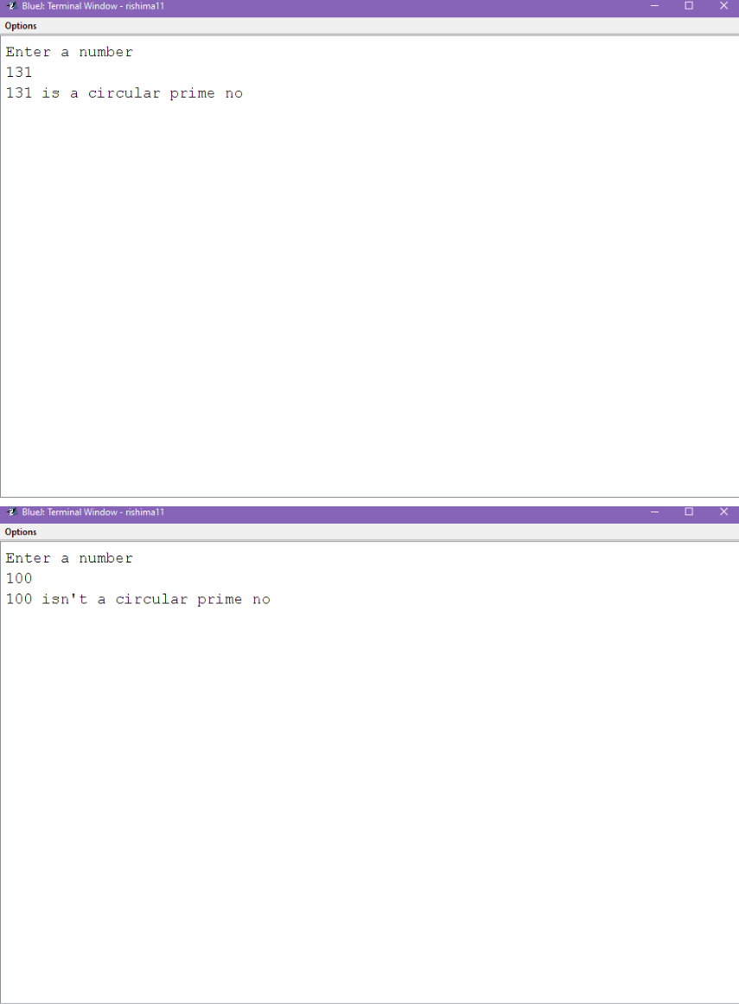

PROGRAM-13

import java.util.Scanner;

class Sum_Diagonal

{

public static void main(String args[])

{

Scanner sc=new Scanner(System.in); int a[][]=new int[3][3]; int r=0,l=0;

System.out.println("Enter the elements in the matrix");

for(int i=0;i<3;i++)

{

for(int j=0;j<3;j++)

a[i][j]=sc.nextInt();

}

System.out.println("the original matrix");

for(int i=0;i<3;i++)

{

for(int j=0;j<3;j++)

System.out.print(a[i][j]);

System.out.println();

}
for(int i=0;i<3;i++)

{

for(int j=0;j<3;j++)

{

if(i==j)

l=l+a[i][j];

}

}

int j=2;

for(int i=0;i<3;i++)

{

if(j>=0)

{

r=r+a[i][j--];

}

}

System.out.println("the sum of left diagonal is=

"+l);

System.out.println("the sum of right diagonal is= "+r);

}

}
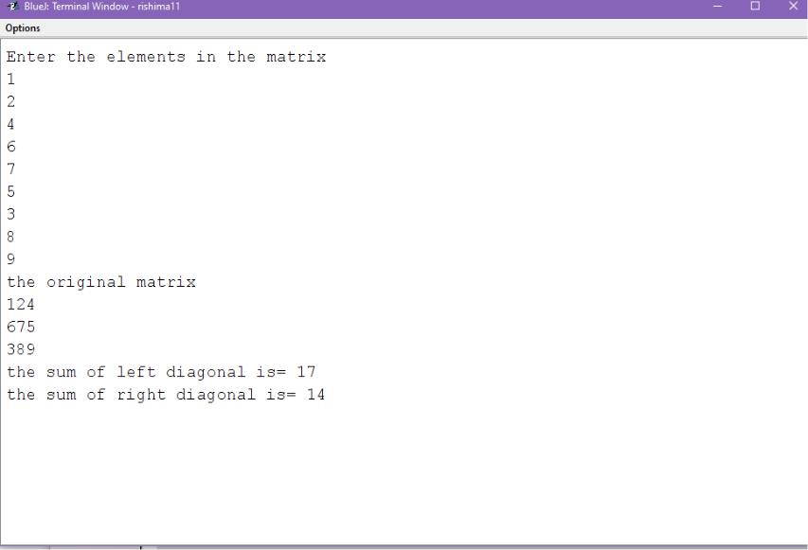

PROGRAM-14

import java.util.Scanner;

class Identity

{

public static void main(String args[])

{

Scanner sc=new Scanner(System.in);

int a[][]=new int[3][3];
int flag=0;

System.out.println("Enter the elements");

for(int i=0;i<3;i++)

{

for(int j=0;j<3;j++)

a[i][j]=sc.nextInt();

}

System.out.println("the original matrix");

for(int i=0;i<3;i++)

{

for(int j=0;j<3;j++)

System.out.print(a[i][j]);

System.out.println();

}

for(int i=0;i<3;i++)

{

for(int j=0;j<3;j++)

{
if(i==j&&a[i][j]==1||i!=j&&a[i][j]==0)

flag=1;

else

flag=0;

}

}

if(flag==1)

System.out.println("it is an identity matrix");

else

System.out.println("it isn't an identity matrix");

}

}
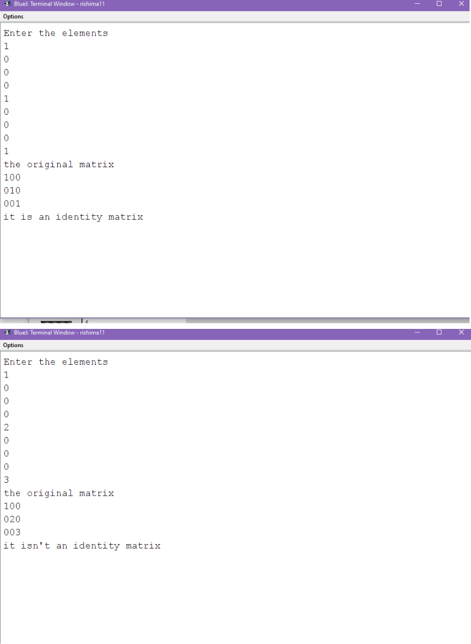

PROGRAM-15

import java.util.Scanner;

class Row_Sorting

{

public static void main(String args[])

{

Scanner sc=new Scanner(System.in); int a[][]=new int[3][3]; int t;

System.out.println("Enter the elements");

for(int i=0;i<3;i++)

{

for(int j=0;j<3;j++)

{

a[i][j]=sc.nextInt();

}

}

System.out.println("the original matrix");

for(int i=0;i<3;i++)

{

for(int j=0;j<3;j++)

System.out.print(a[i][j]);

System.out.println();

}
for(int i=0;i<3;i++)

{

for(int j=0;j<3-1;j++)

{

for(int k=0;k<3-1-j;k++)

{

if(a[i][k]>a[i][k+1])

{

t=a[i][k];

a[i][k]=a[i][k+1];

a[i][k+1]=t;

}

}

}

}

for(int i=0;i<3;i++)

{

for(int j=0;j<3;j++)

System.out.print(a[i][j]+" "); System.out.println();

}

}

}
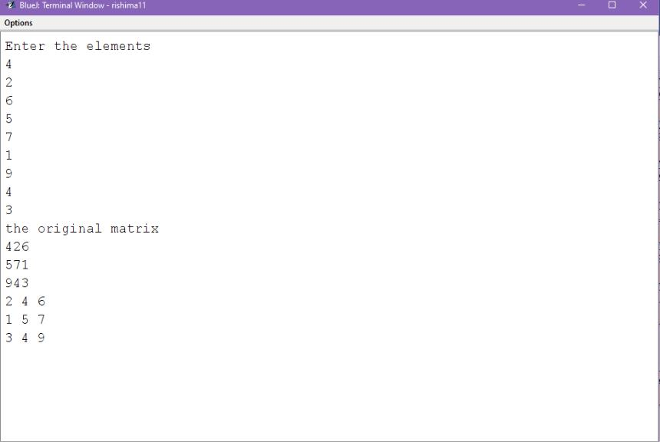

PROGRAM-16

import java.util.Scanner;

class Column_Sort

{

public static void main(String args[])

{

Scanner sc=new Scanner(System.in);
int a[][]=new int[3][3];

int t;

System.out.println("Enter the elements");

for(int i=0;i<3;i++)

{

for(int j=0;j<3;j++)

{

a[i][j]=sc.nextInt();

}

}

System.out.println("the original matrix");

for(int i=0;i<3;i++)

{

for(int j=0;j<3;j++)

System.out.print(a[i][j]);

System.out.println();

}

for(int i=0;i<3;i++)
{

for(int j=0;j<3-1;j++)

{

for(int k=0;k<3-1-j;k++)

{

if(a[k][i]>a[k+1][i])

{

t=a[k][i];

a[k][i]=a[k+1][i];

a[k+1][i]=t;

}

}

}

}

for(int i=0;i<3;i++)

{

for(int j=0;j<3;j++) System.out.print(a[i][j]+" ");
System.out.println();

}

}

}
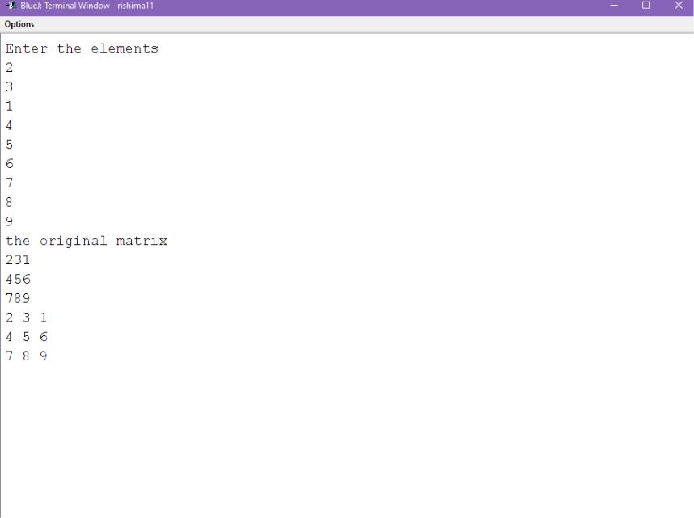

PROGRAM-17

import java.util.Scanner;

class Transpose_Main

{

public static void main(String args[])

{

Transpose obj=new Transpose(); obj.accept();
obj.find_transpose();

obj.print();

}

}

import java.util.Scanner;

class Transpose

{

int a[][],t[][],n,m;

Transpose()

{

n=0;

m=0;

}

Transpose(int u,int v)

{

m=u;

n=u;
}

void accept()

{

Scanner sc=new Scanner(System.in);

System.out.println("Enter the size of the matrix");

n=sc.nextInt();

m=sc.nextInt();

a=new int[m][n];

t=new int[m][n];

System.out.println("Enter the elements");

for(int i=0;i<m;i++)

for(int j=0;j<n;j++)

a[i][j]=sc.nextInt();

}

void find_transpose()

{
for(int i=0;i<m;i++)

for(int j=0;j<n;j++)

{

t[j][i]=a[i][j];

}

}

void print()

{

int flag=0;

System.out.println("The source array:");

for(int i=0;i<m;i++)

{

for(int j=0;j<n;j++)

System.out.print(a[i][j]);

System.out.println();

}

System.out.println("The transpose array:");
for(int i=0;i<m;i++)

{

for(int j=0;j<n;j++)

System.out.print(t[i][j]);

System.out.println();

}

}

}
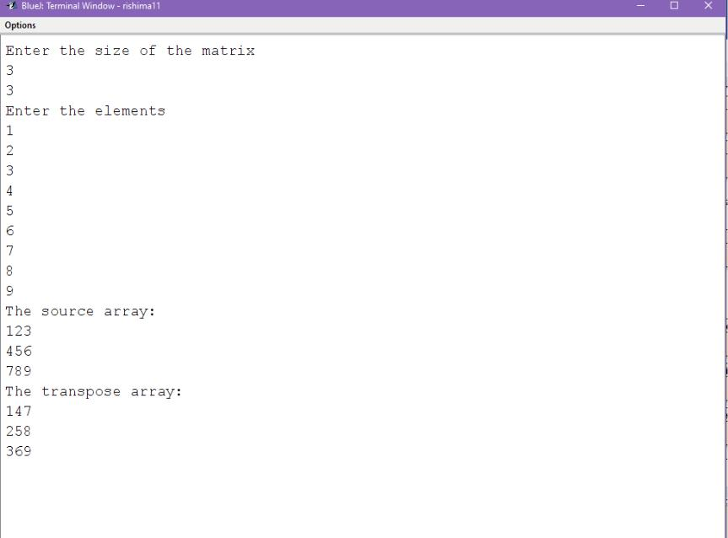

PROGRAM-18

import java.util.Scanner;

class Symmetry
{

public static void main(String args[])

{

int m;

boolean flag=true;

Scanner sc=new Scanner(System.in); System.out.println("Enter the order of matrix"); m=sc.nextInt();

int a[][]=new int [m][m];

int b[][]=new int [m][m];

if(m>2&&m<10)

{

System.out.println("fill the matrix"); for(int i=0;i<m;i++) {

for(int j=0;j<m;j++)

{

a[i][j]=sc.nextInt();
}

}

System.out.println("the original matrix");

for(int i=0;i<m;i++)

{

for(int j=0;j<m;j++)

{

System.out.print(a[i][j]);

}

System.out.println();

}

for(int i=0;i<m;i++)

{

for(int j=0;j<m;j++)

{

b[j][i]=a[i][j];

}

}
for(int i=0;i<m;i++)

{

for(int j=0;j<m;j++)

{

if(a[i][j]!=b[i][j])

{

flag=false;

break;

}

}

}

if(flag==false)

System.out.println("THE GIVEN MATRIX ISN'T SYMMETRIC");

else

System.out.println("THE GIVEN MATRIX IS SYMMETRIC");

}

else

System.out.println("MATRIX SIZE OUT OF RANGE");

}

}
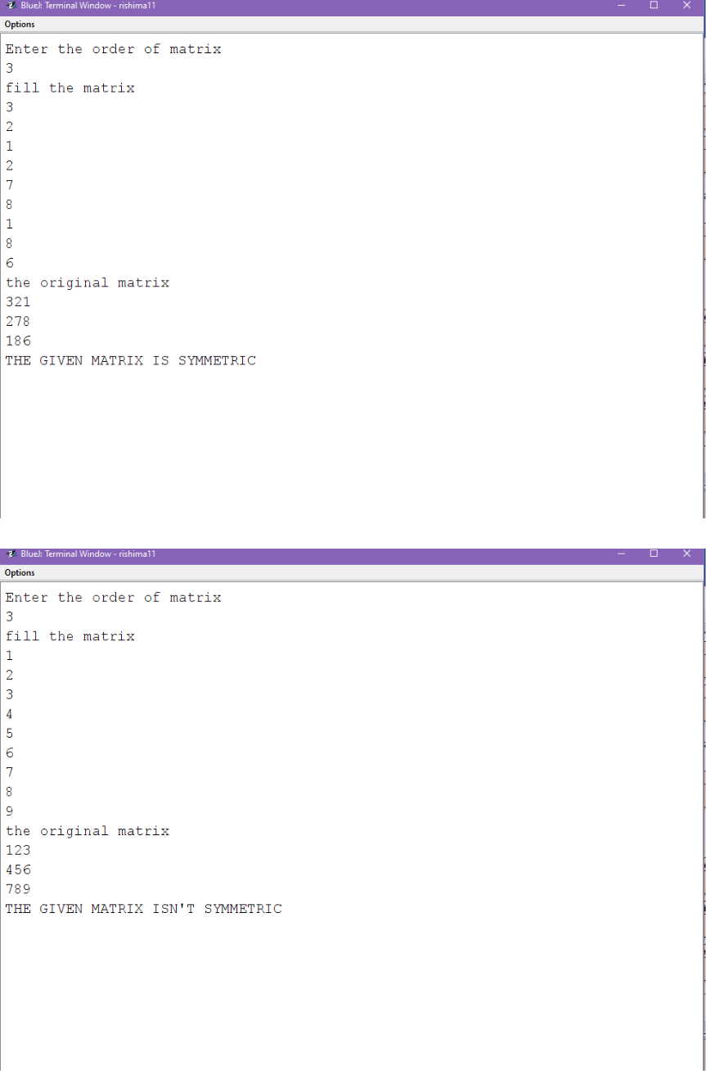

PROGRAM-19

import java.util.*;

class SaddlePoint

{

static boolean findSaddlePoint(int mat[][], int n)

{

for(int i = 0; i < n; i++){

int min_row = mat[i][0], col_ind = 0; for(int j = 1; j < n; j++){

if(min_row > mat[i][j]){

min_row = mat[i][j];

col_ind = j;

}

}

int k;

for (k = 0; k < n; k++){

if (min_row < mat[k][col_ind])

break;

}
if (k == n){

System.out.println("Value of Saddle Point : " + min_row);

return true;

}

}

return false;

}

public static void main(String[] args){ Scanner sc=new Scanner(System.in); System.out.println("Enter size of array :"); int n=sc.nextInt();

int mat[][]=new int[n][n];

System.out.println("Enter the elements of array

:");

for(int i=0;i<n;i++){

for(int j=0;j<n;j++){

mat[i][j]=sc.nextInt();
}

}

if (findSaddlePoint(mat, n) == false) System.out.println("No Saddle Point ");

}

}
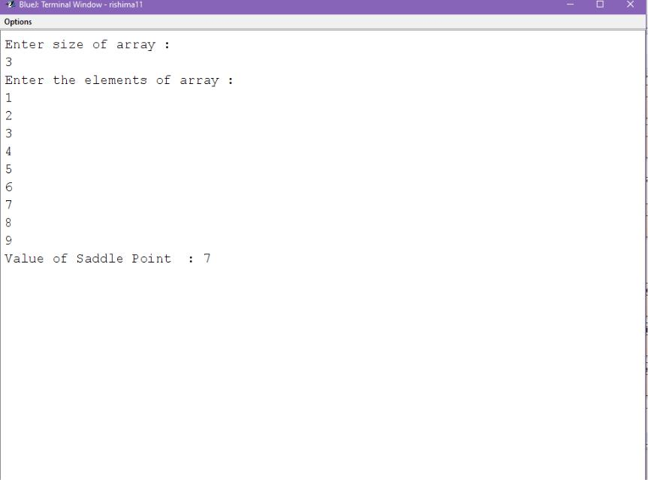

PROGRAM-20

import java.util.Scanner;

class Bound_sum

{

public static void main(String args[])
{

Scanner sc=new Scanner(System.in); int m,b_s=0,nb_s=0; System.out.println("Enter the limit"); m=sc.nextInt();

int a[][]=new int[m][m]; System.out.println("fill the matrix");

for(int i=0;i<m;i++)

{

for(int j=0;j<m;j++)

{

a[i][j]=sc.nextInt();

}

}

for(int i=0;i<m;i++)

{

for(int j=0;j<m;j++)

{
if(i==0||i==(m-1)||j==0||j==(m-1))

b_s=b_s+a[i][j];

else

nb_s=nb_s+a[i][j];

}

}

System.out.println("the sum of boundary elements is-"+b_s);

System.out.println("the sum of non-boundary elements is-"+nb_s);

}

}
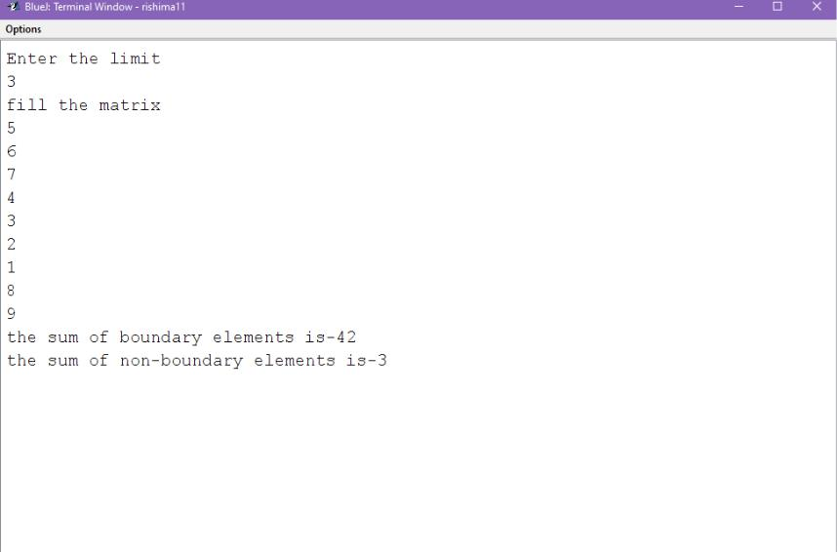

PROGRAM-21

import java.util.Scanner;

class Stack_Main

{

public static void main (String[] args)

{

Scanner sc=new Scanner(System.in);

System.out.println("Enter the size of the stack");

int s=sc.nextInt();

Stack obj=new Stack(s);

System.out.println("\n 1.push \t 2. pop \t 3.display \t 4. Exit");

boolean flag=true;

while(flag)

{

System.out.println("\nEnter your choice:");

int c=sc.nextInt();

switch(c)

{
case 1:

System.out.println("Enter an element for insertion");

int x=sc.nextInt();

obj.push(x);

break;

case 2:

obj.pop();

break;

case 3:

obj.display();

break;

case 4:

flag=false;

break;

default:

System.out.println("Please enter a valid choice");

break;

}
}

}

}

import java.util.Scanner;

class Stack

{

int a[],top,size;

Stack()

{

size=0;

}

Stack(int i)

{

size=i;

a=new int[size];

top=-1;
}

void push(int j)

{

if(top==size-1)

System.out.println("Stack Overflow");

else

a[++top]=j;

}

void pop()

{

int k;

if(top==-1)

System.out.println("Stack Underflow");

else

{

k=a[top--];
System.out.println("Element deleted is="+k);

}

}

void display()

{

System.out.println("Elements of the stack are as follows:\n");

for(int i=0;i<=top;i++)

System.out.print(a[i]+" ");

}

}
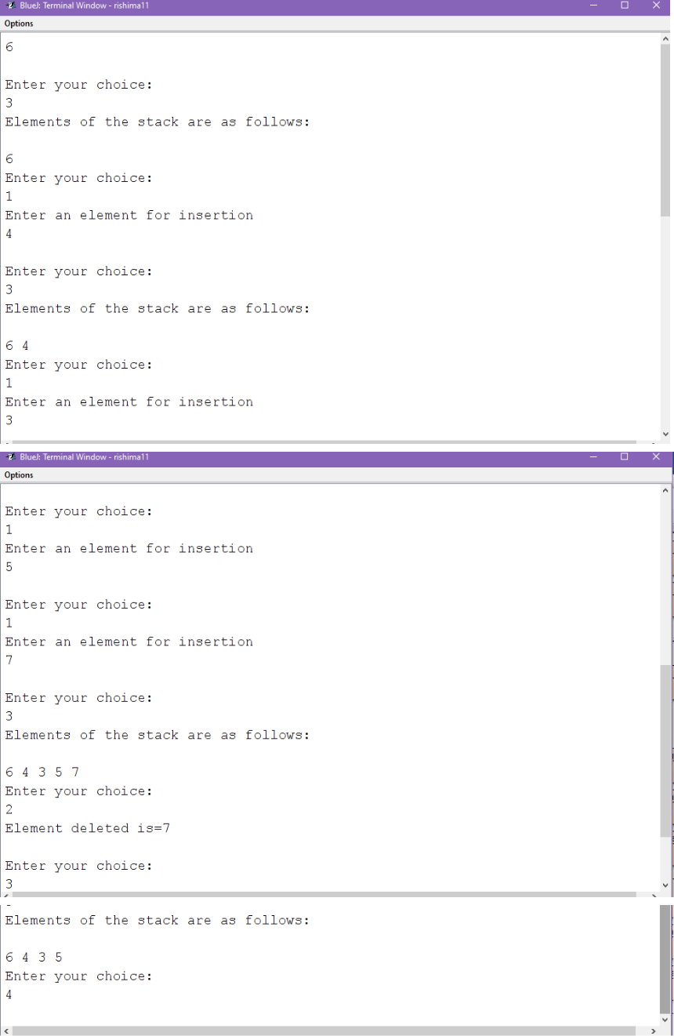

PROGRAM-22

import java.util.Scanner;

class Queue_Main

{

public static void main (String[] args)
{

Scanner sc=new Scanner(System.in); System.out.println("Enter the size of the queue"); int s=sc.nextInt();

Queue obj=new Queue(s);

System.out.println("\n1. insert \t 2. delete \t 3. display \t 4.Exit");

boolean flag=true;

while(flag)

{

System.out.println("\nEnter your choice:");

int c=sc.nextInt();

switch(c)

{

case 1:

System.out.println("Enter an element for insertion");

int x=sc.nextInt();

obj.insert(x);
break;

case 2:

obj.delete();

break;

case 3:

obj.display();

break;

case 4:

flag=false;

break;

default:

System.out.println("Please enter a valid choice");

break;

}

}

}

}

import java.util.Scanner;
class Queue

{

int a[],front,rear,size;

Queue(int n)

{

size=n;

a=new int[size];

front=rear=-1;

}

void insert(int x)

{

if(rear==size-1)

{

System.out.println("Queue Overflow");

return;

}

a[++rear]=x;

if(front==-1)
front=0;

}

void delete()

{

int x;

if(front==-1)

{

System.out.println("Queue Underflow");

return ;

}

x=a[front];

System.out.println("Element deleted is="+x);

if(front==rear)

front=rear=-1;

else

front++;
}

void display()

{

if(front==-1)

{

System.out.println("Queue empty");

return ;

}

for(int i=front;i<=rear;i++)

System.out.print(a[i]+" ");

}

}
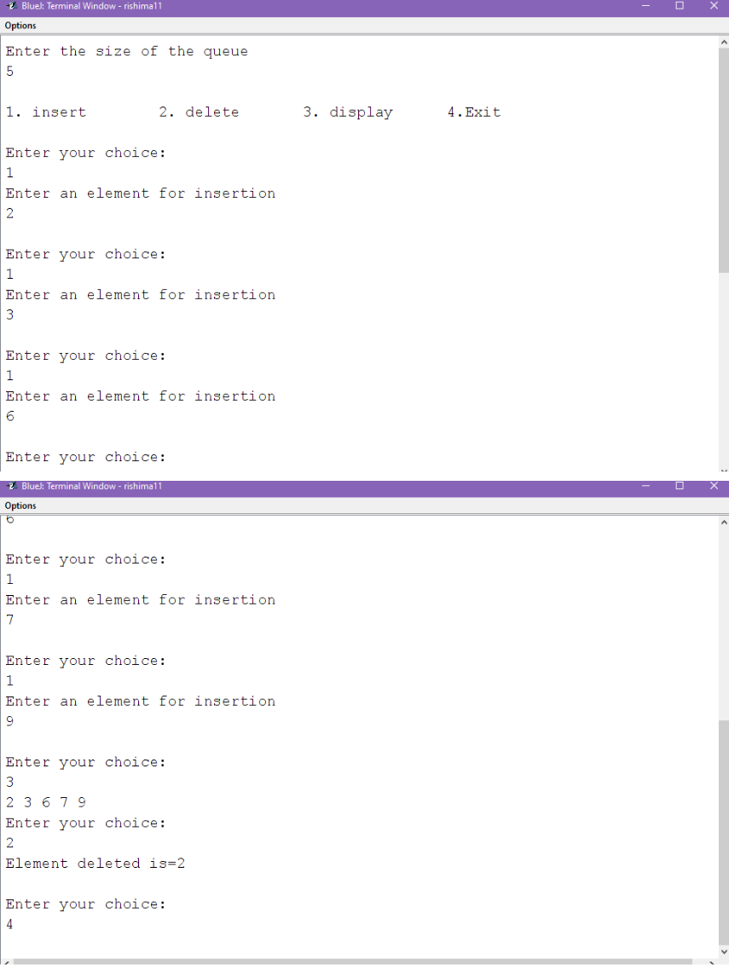

PROGRAM-23

import java.util.Scanner;

class Circularqueue_Main

{

public static void main (String[] args)

{

Scanner sc=new Scanner(System.in);

System.out.println("Enter the size of the queue"); int s=sc.nextInt();

Circular_Queue obj=new Circular_Queue(s);

System.out.println("\n1. insert \t 2. delete \t 3. display \t 4. Exit");

boolean flag=true;

while(flag)

{

System.out.println("\nEnter your choice:");

int c=sc.nextInt();

switch(c)

{

case 1:

System.out.println("Enter an element for insertion");

int x=sc.nextInt();

obj.insert(x);

break;
case 2:

obj.delete();

break;

case 3:

obj.display();

break;

case 4:

flag=false;

break;

default:

System.out.println("Please enter a valid choice");

break;

}

}
}

}

import java.util.Scanner;

class Circular_Queue

{

int q[],front,rear,size;

Circular_Queue(int n)

{

size=n;

q=new int[size];

front=rear=-1;

}

void insert(int x)

{

if((rear==size-1 && front==0) || (front==rear+1)) System.out.println("Queue Overflow"); else if (front==-1) //insert 1st element
{

front=rear=0;

q[rear]=x;

}

else if(rear==size-1 && front>0)

{

rear=0; q[rear]=x;

}

else

{

rear++; q[rear]=x;

}

}

void delete()

{

int x;

if(front==-1)

{

System.out.println("Queue Underflow"); return;

}

x=q[front];

System.out.println("Element deleted is="+x);

q[front]=-1;

if(front==rear)

front=rear=-1;

else if(front==size-1)

front=0;

else

front++;

}

void display()

{

if(front==-1)

{

System.out.println("Queue empty");
return;

}

if(rear>=front)

{

for(int i=front;i<=rear;i++)

System.out.print(q[i]+" ");

}

else

{

for(int i=front;i<size;i++)

System.out.print(q[i]+" ");

for(int i=0;i<=rear;i++)

System.out.print(q[i]+" ");

}

}

}
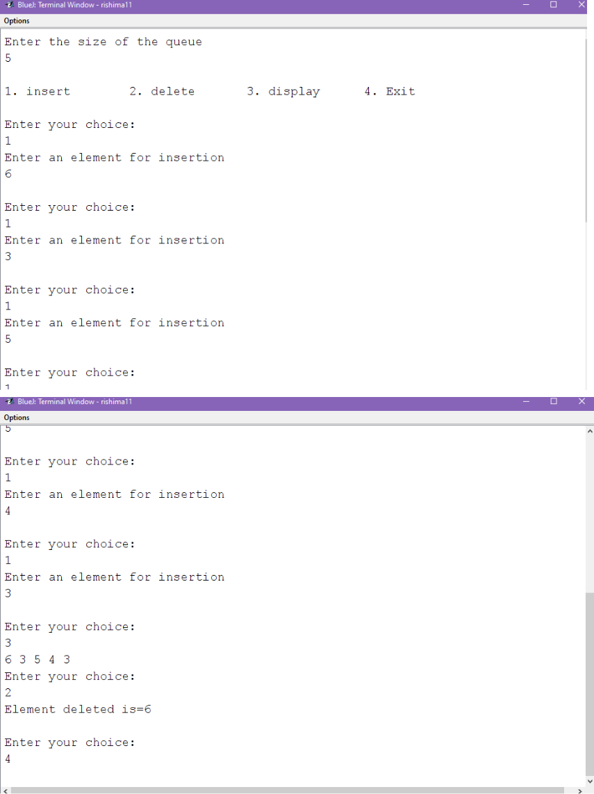

PROGRAM-24

import java.util.*;

class GFG {

static void spiralFill(int m, int n, int a[][]){ int val = 1;

int k = 0, l = 0;

while (k < m && l < n)
{

for (int i = l; i < n; ++i)

{

a[k][i] = val++;

}

k++;

for (int i = k; i < m; ++i)

{

a[i][n - 1] = val++;

}

n--;

if (k < m)

{

for (int i = n - 1; i >= l; --i) {

a[m - 1][i] = val++;

}

m--;
}

if (l < n) {

for (int i = m - 1; i >= k; --i) {

a[i][l] = val++;

}

l++;

}

}

}

public static void main(String[] args){ Scanner sc=new Scanner(System.in); System.out.println("Enter the size :"); int n=sc.nextInt();

int a[][] = new int[n][n];

spiralFill(n,n,a);

for (int i = 0; i < n; i++) {

for (int j = 0; j < n; j++) {
System.out.print(a[i][j] + " ");

}

System.out.println("");

}

}

}
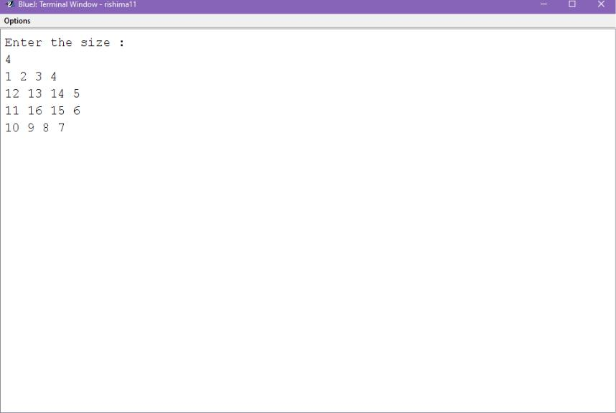

PROGRAM-25

import java.util.*;

class BoundarySort

{

public static void main(String args[])

{

Scanner sc=new Scanner(System.in); System.out.println("Enter size of array :"); int m=sc.nextInt();

int mat[][]=new int[m][m];

int n=(m*2+(m-2)*2);

int a[]=new int[n];

int index=0;

if(m>3&&m<10)

{

System.out.println("Enter the elements of array

:");

for(int i=0;i<m;i++)

{

for(int j=0;j<m;j++)

{

mat[i][j]=sc.nextInt();

if(i == 0 || j == 0 || i == m - 1 || j == m - 1)

{
a[index++] = mat[i][j];

}

}

}

System.out.println("Original matrix:");

for(int i = 0; i < m; i++){

for(int j = 0; j < m; j++){

System.out.print(mat[i][j] + " ");

}

System.out.println();

}

int temp;

for(int i = 0; i < n; i++)

{

for(int j = 0; j < n - 1 - i; j++)

{

if(a[j] > a[j + 1]){

temp = a[j];
a[j] = a[j + 1];

a[j + 1] = temp;

}

}

}

index = 0;

for(int i = 0; i < m; i++)

mat[0][i] = a[index++];

for(int i = 1; i < m; i++) mat[i][m - 1] = a[index++];

for(int i = m - 2; i >= 0; i--) mat[m - 1][i] = a[index++];

for(int i = m - 2; i >= 1; i--)

mat[i][0] = a[index++];

System.out.println("Rearranged matrix:"); for(int i = 0; i < m; i++){

for(int j = 0; j < m; j++){
System.out.print(mat[i][j] + " ");

}

System.out.println();

}

}

else

System.out.println("Invalid range");

}

}
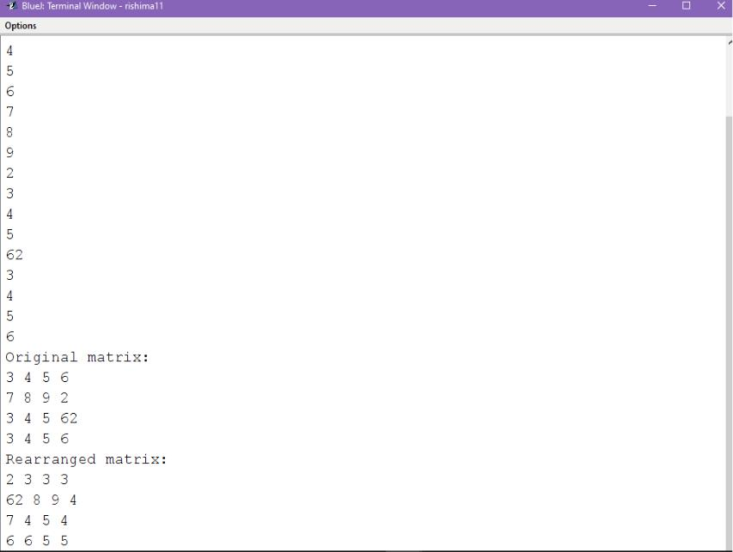

PROGRAM-26

import java.util.Scanner;
class Find{

public static void main(String args[]){

Scanner sc=new Scanner(System.in);

int n, day, year, i, p, k=0;

int ar[]={0, 31, 59, 90, 120, 151, 181, 212, 243, 273, 304, 334, 365};

String br[]={"", "January", "February", "March", "April", "May", "June", "July", "August", "September", "October", "November", "December"};

System.out.print("Day number");

day = sc.nextInt();

System.out.print("Year");

year = sc.nextInt();

System.out.print("N: ");

n = sc.nextInt();

p = day + n;

int a = 1, b = 1, date = 0, nday = 0, year1 = year;

if(year % 4 == 0){

for(i = 2; i <= 12; i++){
ar[i] += 1;

}

if(day >= 1 && day <= 366){

for(i = 0; i <= 12; i++){

if(ar[i] < day)

a = i;

if(ar[i] > day)

break;

}

date = day - ar[a];

}

else

k = 1;

if(k == 1)

System.out.println("Days are out of Range"); else if(k != 1 && n >= 1 && n <= 100){

if(p > ar[12]){

p = p - ar[12];
year1 = year1 + 1;

}

for(i = 0; i <= 12; i++){

if(ar[i] < p)

b = i;

if(ar[i] > p)

break;

}

nday = p - ar[b];

}

else{

k = 1;

System.out.println("N Days are out of range

");

}

if(k != 1){

System.out.println("Date is : " + date + "th " + br[a + 1] + " " + year);

System.out.println("N Date is : "+ nday + "th " + br[b + 1] + " " + year1);

}

}

else{

if(day >=1 && day <= 365){

for(i = 0; i <= 12; i++){

if(ar[i] < day)

a = i;

if(ar[i] > day)

break;

}

date = day - ar[a];

}

else

k = 1;

if(k == 1)

System.out.println("Days are out of Range");
if(n >= 1 && n <= 100){

if(p > ar[12]){

p = p - ar[12];

year1 = year1 + 1;

}

for(i = 0; i <= 12; i++){

if(ar[i] < p){

b = i;

}

if(ar[i] > p)

break;

}

nday = p - ar[b];

}

else{

k = 1;

System.out.println("N days are out of range ");

}
if(k != 1){

System.out.println("Date is : "+date+"th " + br[a+1]+" "+year);

System.out.println("N Date is : "+nday+"th " + br[b+1]+" "+year1);

}

}

}

}
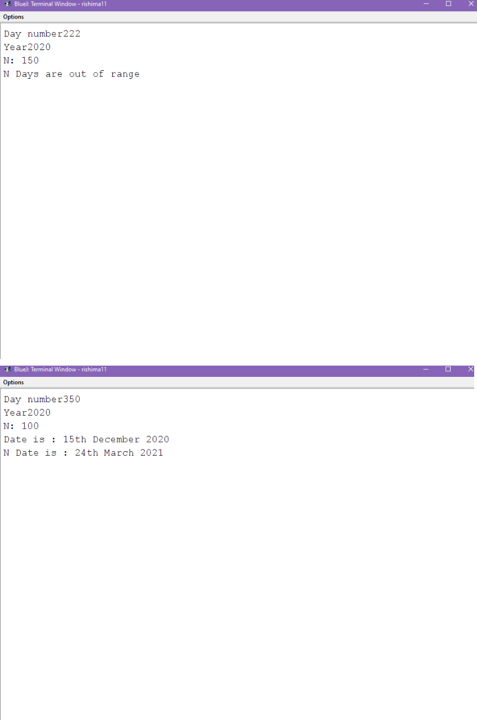

PROGRAM-27

import java.util.Scanner;

class woells{

public static void main(String args[])

{
Scanner sc=new Scanner(System.in);

System.out.print("Sentence ending wit'.','?','!': ");

String s = sc.nextLine();

s = s.trim();

s = s.toUpperCase();

int len = s.length();

char last = s.charAt(len - 1);

if(last != '.' && last != '?' && last != '!'){ System.out.println("INVALID INPUT"); return;

}

String word = new String();

String v = new String();

String nv = new String();

int count = 0;

for(int i = 0; i < len; i++){

char ch = s.charAt(i);

switch(ch){
case ' ':

case '.':

case '?':

case '!':

if(word.length() > 0 && testWord(word)){ count++;

v += word + " ";

}

else if(word.length() > 0)

nv += word + " ";

word = new String();

break;

default:

word += ch;

}

}

System.out.println("NUMBER OF WORDS BEGINNING AND ENDING WITH A VOWEL = " + count);
System.out.println(v + nv);

}

public static boolean testWord(String w){ int len = w.length();

char first = w.charAt(0); char last = w.charAt(len - 1); if(isVowel(first) && isVowel(last))

return true;

return false;

}

public static boolean isVowel(char ch){ switch(ch){

case 'A':

case 'E':

case 'I':

case 'O':

case 'U':

return true;
default:

return false;

}

}

}
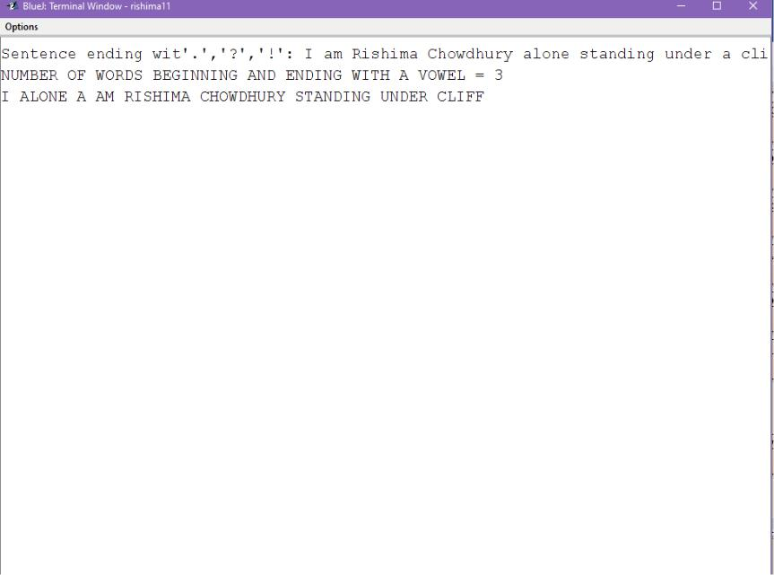

PROGRAM-28

import java.util.*;

class Evil{

static int convBinary(int n){

int bin=0;

while(n>0){

bin=bin*10+(n%2);
n=n/2;

}

return bin;

}

public static void main(String args[]){ Scanner sc=new Scanner(System.in); System.out.print("INPUT A NUMBER : "); int n=sc.nextInt();

int binary = convBinary(n);

int c=0,d,copy=binary;

while(binary>0){

if((binary%10)==1)

c++;

binary=binary/10;

}

System.out.println("INPUT : "+n);
System.out.println("BINARY EQUIVALENT :

"+copy);

System.out.println("NUMBER OF 1's : "+c);

System.out.print("OUTPUT : ");

if(c%2==0)

System.out.println("EVIL NUMBER");

else

System.out.println("NOT EVIL NUMBER");

}

}
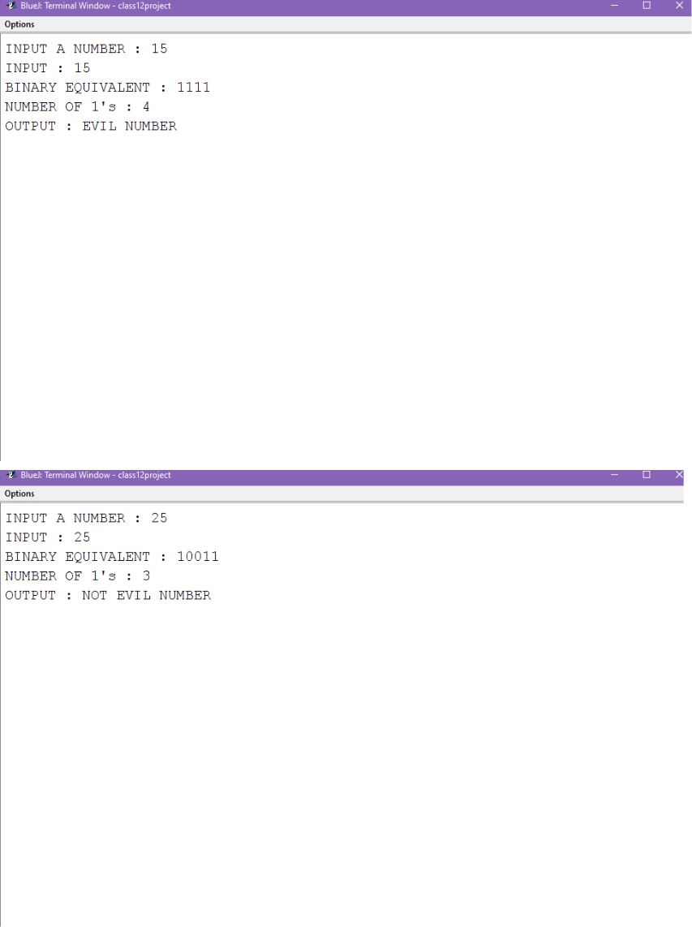

PROGRAM-29

import java.util.*;

class Potential{

static int potentialOf(String w){

char c;

int p=0;

for(int i=0;i<w.length();i++){
c=w.charAt(i);

p=p+((int)c-64);

}

return p;

}

public static void main(String args[]){

Scanner sc=new Scanner(System.in);

System.out.println("Enter a string :");

String s=sc.nextLine();

StringTokenizer st=new StringTokenizer(s);

int n=st.countTokens();

String words[]=new String[n];

int potential[]=new int[n];

int i=0;

String word;

while(st.hasMoreTokens()){

word=st.nextToken();
words[i]=word;

potential[i]=potentialOf(word);

i++;

}

String temp;

int t;

for (int j = 0; j < n - 1; j++){ for (int k = j + 1; k < n; k++){

if (potential[j]>potential[k]){ temp = words[j]; words[j] = words[k]; words[k] = temp;

t = potential[j];

potential[j] = potential[k];

potential[k] = t;

}

}

}

System.out.println("Changed string : "); for(i=0;i<n;i++){

System.out.print(words[i]+" ");

}

}

}
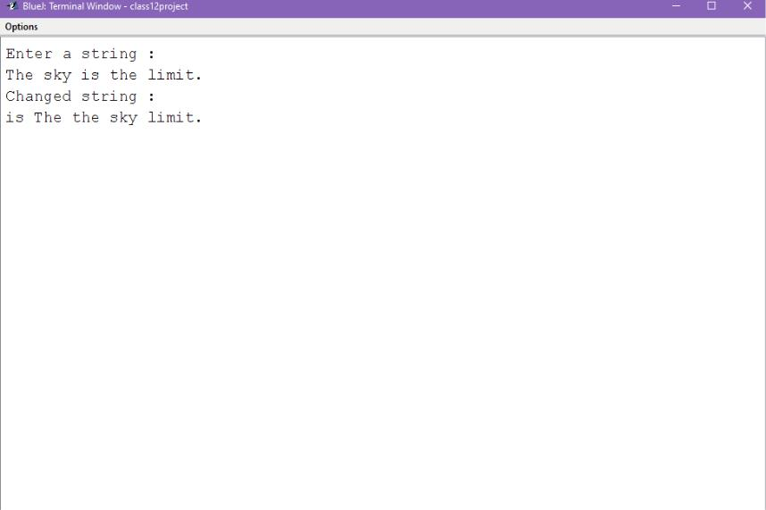

PROGRAM-30

import java.util.Scanner;

class Diagonal

{

public static void main(String args[])
{

int m,n,c=0,d=0,b=0;

Scanner sc=new Scanner(System.in);

System.out.println("enter the limits of the matrix");

m=sc.nextInt();

n=sc.nextInt();

int a[][]=new int[m][n];

System.out.println("enter the elements in the matrix");

for(int i=0;i<m;i++) for(int j=0;j<n;j++) a[i][j]=sc.nextInt(); System.out.println("the matrix is:"); for(int i=0;i<m;i++) {

for(int j=0;j<n;j++)

System.out.print(a[i][j]);

System.out.println();
}

for(int i=0;i<m;i++)

{

for(int j=0;j<n;j++)

{

if(i==j)

{

if(a[i][j]==0)

b++;

else if(a[i][j]!=0)

c++;

}

else

{

if(a[i][j]==0)

d++;

}

}
}

if(c==(m-b)&&d==((m*n)-m)&&b!=m)

System.out.print("It is a diagonal matrix");

else

System.out.print("It isn't a diagonal matrix");

}

}
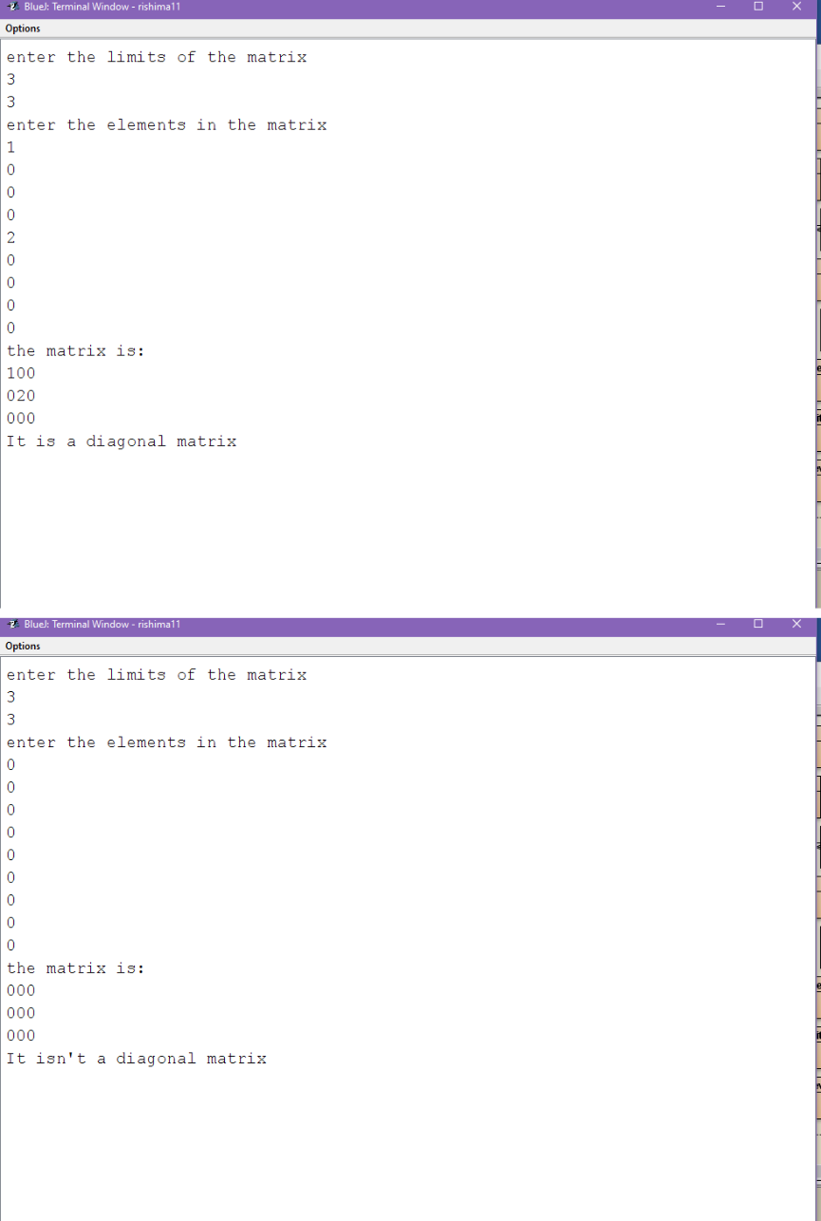

PROGRAM-31

import java.util.*;

class Saddle

{

static boolean findSaddlePoint(int mat[][], int n)
{

for(int i = 0; i < n; i++){

int min_row = mat[i][0], col_ind = 0; for(int j = 1; j < n; j++){

if(min_row > mat[i][j]){

min_row = mat[i][j];

col_ind = j;

}

}

int k;

for (k = 0; k < n; k++){

if (min_row < mat[k][col_ind])

break;

}

if (k == n){

System.out.println("Value of Saddle Point : " + min_row);

return true;
}

}

return false;

}

public static void main(String[] args){ Scanner sc=new Scanner(System.in); System.out.println("Enter size of array :"); int n=sc.nextInt();

int mat[][]=new int[n][n];

System.out.println("Enter the elements of array

:");

for(int i=0;i<n;i++){

for(int j=0;j<n;j++){

mat[i][j]=sc.nextInt();

}

}

System.out.println("The source array:");
for(int i=0;i<n;i++)

{

for(int j=0;j<n;j++) System.out.print(mat[i][j]); System.out.println();

}

if (findSaddlePoint(mat, n) == false) System.out.println("No Saddle Point ");

}

}
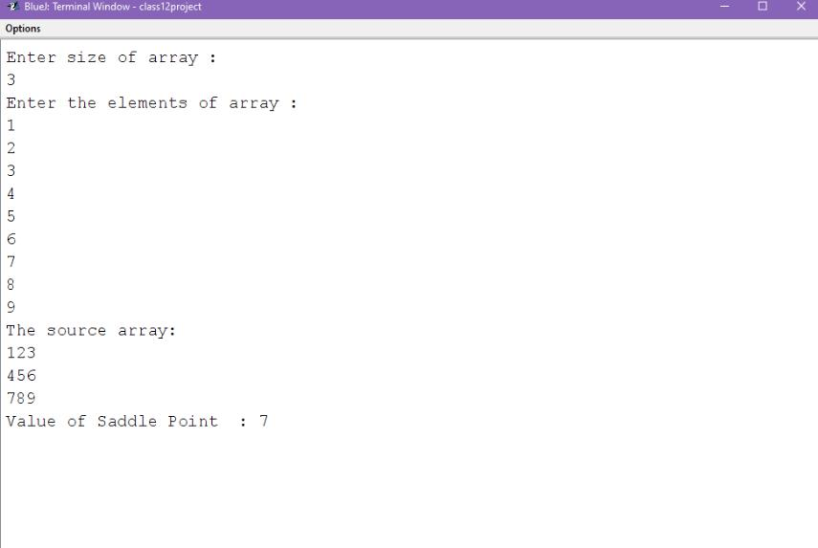

PROGRAM-32

import java.util.Scanner;

class AlphaFrequency

{

public static void main(String args[])

{

Scanner sc=new Scanner(System.in);;

System.out.print("Enter any string: ");

String s = sc.nextLine();

s=s.toLowerCase();

int l=s.length();

char ch;

System.out.println("Output:");

System.out.println("==========================");

System.out.println("Alphabet\tFrequency");

System.out.println("==========================");
int count=0;

for(char i='a'; i<='z'; i++)

{

count = 0;

for(int j=0; j<l; j++)

{

ch=s.charAt(j);

if(ch==i)

count++;

}

if(count!=0)

{

System.out.println(i+"\t\t"+count);

}

}

}
}
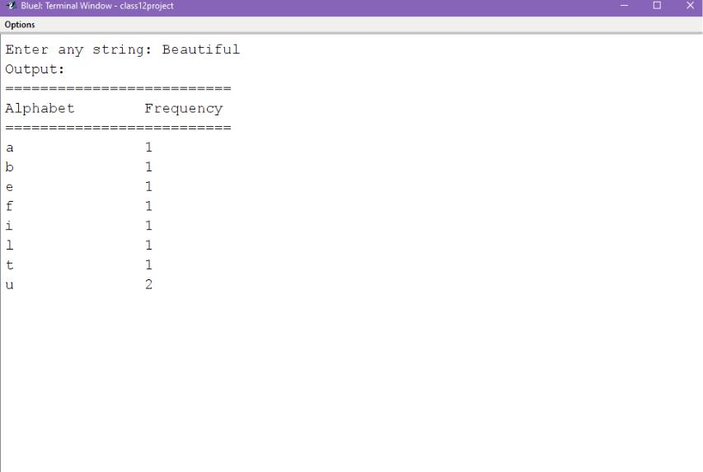

PROGRAM-33

import java.util.Scanner;

class UniqueNumber

{

static boolean isUnique(int number)

{

int n1 = number;

int lastDigit = 0;

int n2;
int count;

while(n1 != 0)

{

lastDigit = n1 % 10;

n2 = number;

count = 0;

while(n2 != 0)

{

if(lastDigit == n2%10)

count++;

n2 /= 10;

}

if(count != 1)

return false;

n1 /= 10;

}

return true;

}

public static void main(String[] args)

{

int number = 0;

boolean result = false;

Scanner sc = new Scanner(System.in);

System.out.print("Enter an integer number::");

number = sc.nextInt();

result = isUnique(number);

if(result)

System.out.println(number +" is an Unique number.");

else

System.out.println(number +" is not an Unique number.");

}

}
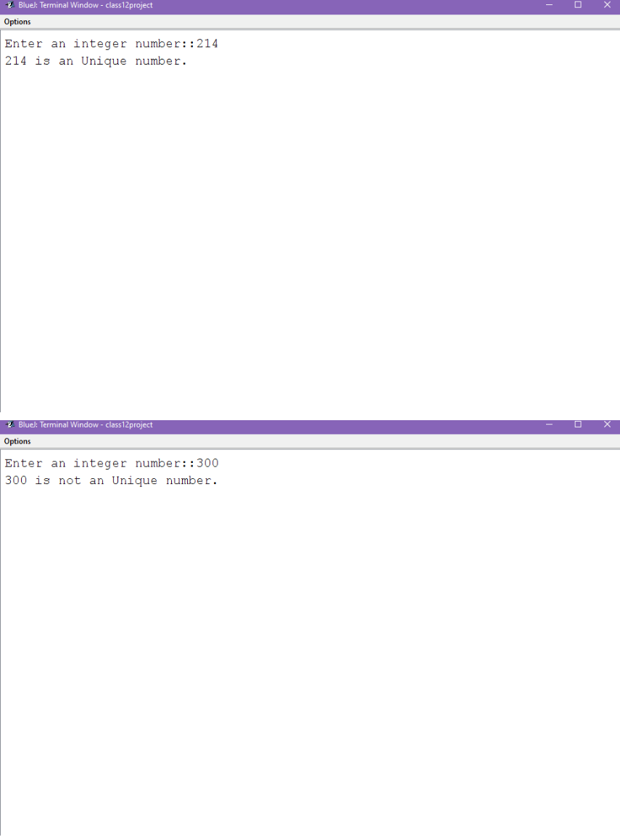

PROGRAM-34

import java.util.Scanner;

class Prime_Main

{

public static void main(String args[])

{
int n,x;

Scanner sc=new Scanner(System.in); System.out.println("enter a number"); n=sc.nextInt();

Prime obj=new Prime();

x=obj.Prime(n,2);

if(x==1)

System.out.println(n+"is a prime number"); else

System.out.println(n+"isn't a prime number");

}

}

class Prime

{

int Prime(int y,int i)

{

if(i<y)

{
if(y%i!=0)

{

return(Prime(y,++i));

}

else

{

return 0;

}

}

return 1;

}

}
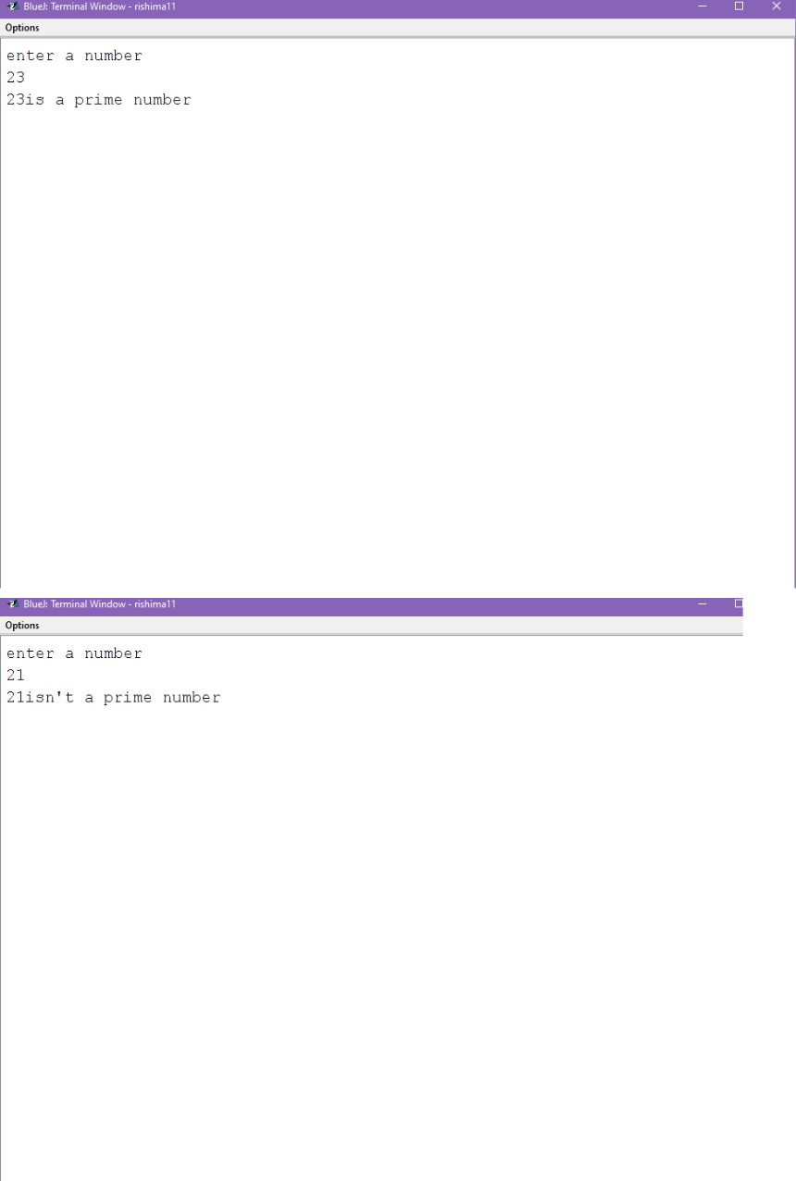

PROGRAM-35

import java.util.Scanner;

class Fibonacci_Main

{

public static void main(String args[])
{

Fibonacci obj=new Fibonacci(); int a,x;

Scanner sc=new Scanner(System.in);

System.out.println("Enter a limit");

a=sc.nextInt();

x=obj.fib(a);

System.out.println("The fibonacci series is: "+x);

}

}

class Fibonacci

{

int fib(int n)

{

if(n<=1)

return n;

else

return fib(n-1)+fib(n-2);
}

}
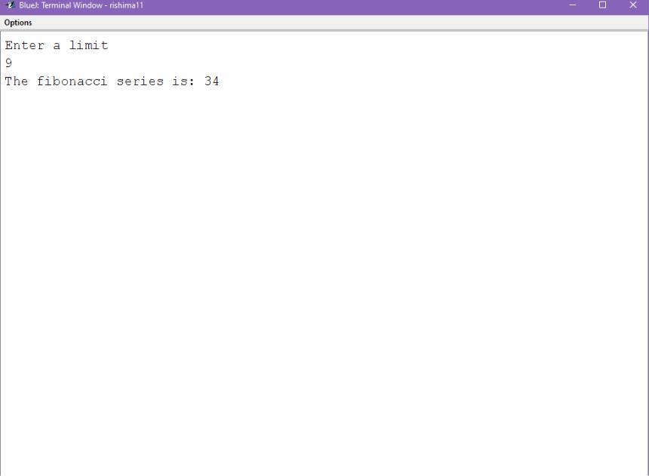

PROGRAM-36

import java.util.Scanner;

class GCD_Main

{

public static void main(String args[])

{

Scanner sc=new Scanner(System.in); int a,b,r;

System.out.println("Enter two numbers"); a=sc.nextInt();
b=sc.nextInt();

GCD obj=new GCD();

r=obj.gcd(a,b);

System.out.println("the Greatest common divisor "+r);

}

}

import java.util.*;

class GCD

{

int gcd(int m,int n)

{

if(m>=n&&m%n==0)

return n;

else

return gcd(n,m%n);

}

}
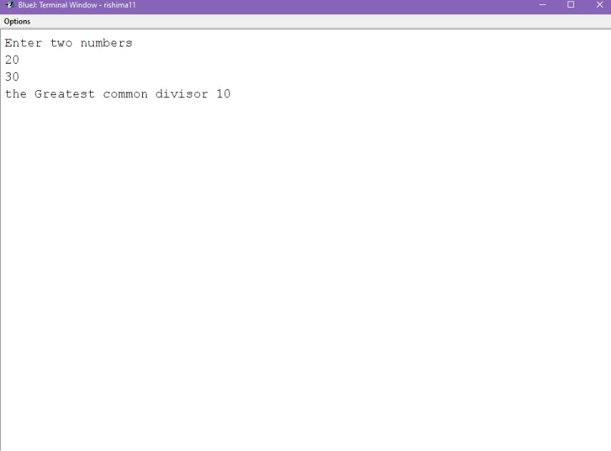

PROGRAM-37

import java.util.Scanner; public class ReverseString {

public static void main(String[] args) {

String s;

System.out.println("Enter The string: "); Scanner scanner = new Scanner(System.in); s = scanner.nextLine(); Rev_str obj=new Rev_str();

obj.reverse(s);

}
}

class Rev_str

{

void reverse(String str)

{

if ((str==null)||(str.length() <= 1))

System.out.println(str);

else

{

System.out.print(str.charAt(str.length()-1));

reverse(str.substring(0,str.length()-1));

}

}

}
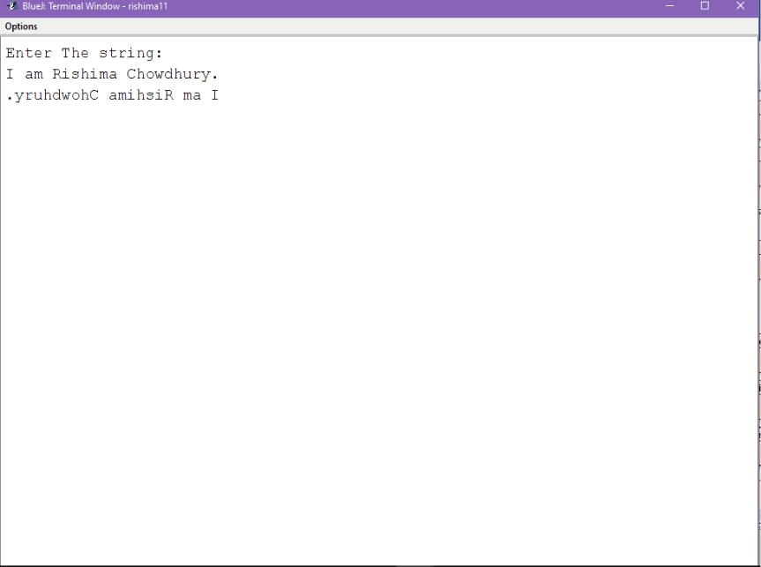

PROGRAM-38

import java.util.Scanner;

class Binarysearch_rec

{

int rec_bin_search(int my_arr[], int left, int right, int x)

{

if (right >= left)

{

int mid = left + (right - left) / 2; if (my_arr[mid] == x) return mid;
if (my_arr[mid] > x)

return rec_bin_search(my_arr, left, mid - 1, x); return rec_bin_search(my_arr, mid + 1, right, x);

}

return -1;

}

public static void main(String args[])

{

Scanner sc=new Scanner(System.in);

Binarysearch_rec my_object = new Binarysearch_rec();

System.out.println("Enter the size of array :");

int n=sc.nextInt();

int a[]=new int[n];

System.out.println("Enter the elements of the array in asscending order : ");

for(int i=0;i<n;i++){

a[i]=sc.nextInt();
}

System.out.println("Enter the number to search :

");

int num=sc.nextInt();

int result = my_object.rec_bin_search(a, 0, n - 1, num);

if (result == -1)

System.out.println("The element is not present in the array");

else

System.out.println("The element has been found at index " + result);

}

}
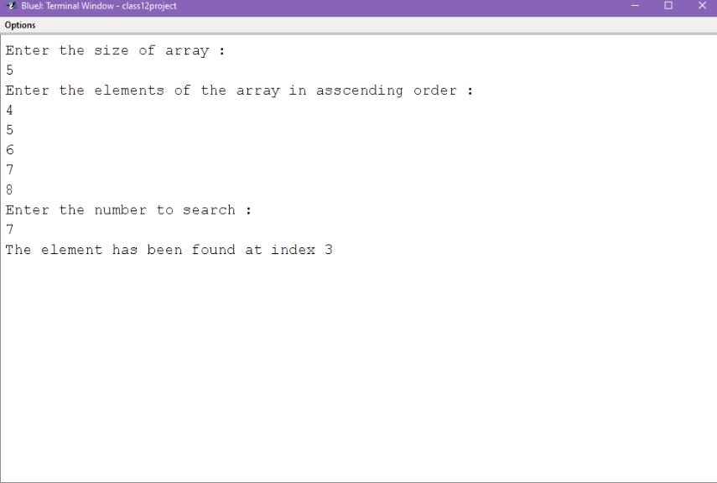

PROGRAM-39

import java.util.Scanner;

class Peri_main

{

public static void main(String args[])

{

double x,y,z;

Scanner sc=new Scanner(System.in);

System.out.println("enter the length,breadth,height");

x=sc.nextDouble();

y=sc.nextDouble();
z=sc.nextDouble();

Area obj=new Area(x,y,z);

obj.doArea();

obj.show();

}

}

class Area extends Perimeter{ double h;

double area;

public Area(double length, double width, double height){

super(length, width);

h = height;

area = 0.0;

}

public void doArea(){

area = b * h;

}
public void show(){

super.show();

System.out.println("Height: " + h);

System.out.println("Area: " + area);

}

}

class Perimeter

{

double a;

double b;

public Perimeter(double length, double width)

{

a = length;

b = width;

}

public double calculate()

{
return 2.0 * (a + b);

}

public void show(){

System.out.println("Length: " + a);

System.out.println("Breadth: " + b);

System.out.println("Perimeter: " + calculate());

}

}
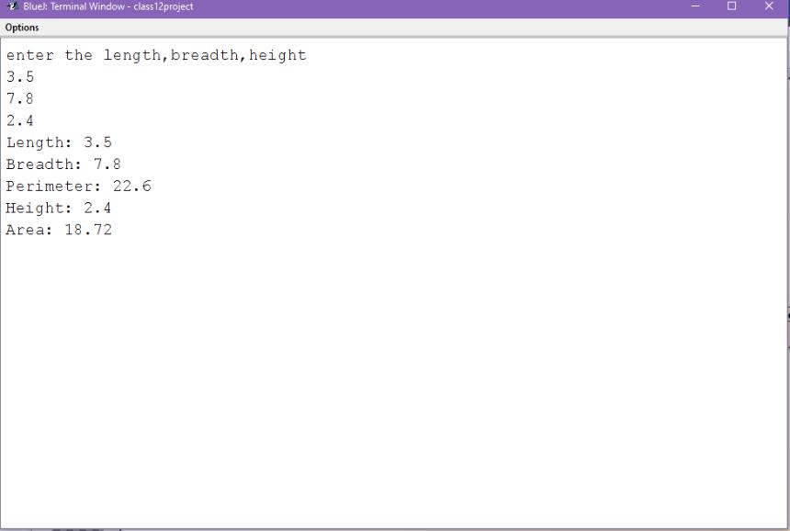

PROGRAM-40

import java.util.Scanner;

class Bank_Main
{

public static void main(String args[])

{

String p,q;

int r,s;

Scanner sc=new Scanner(System.in);

System.out.println("enter the name,account number,principal amount,amount to withdrawn");

p=sc.nextLine();

q=sc.nextLine();

r=sc.nextInt();

s=sc.nextInt();

Account obj=new Account(p,q,r,s);

System.out.println("1.deposit"+"\n"+"2.withdraw");

int c;

c=sc.nextInt();

switch(c)

{
case 1:

obj.deposit();

obj.display();

break;

case 2:

obj.withdraw();

obj.display();

break;

default:

System.out.println("Invalid choice!");

}

}

}

class Account extends Bank

{

int amt;
Account(String w,String x,int y,int z)

{

super(w,x,y);

amt=z;

}

void deposit()

{

p=p+amt;

}

void withdraw()

{

if(amt>p)

System.out.println("INSUFFICIENT BALANCE");

else

p=p-amt;

if(p<500)
p=p-(500-p)/10;

}

void display()

{

super.display();

}

}

class Bank

{

String name,accno;

int p;

Bank(String a,String b,int c)

{

name=a;

accno=b;

p=c;

}

void display()

{

System.out.println("the name "+name);

System.out.println("the account number "+accno);

System.out.println("the principal amount "+p);

}

}
